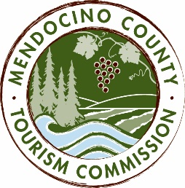

MENDOCINO COUNTY TOURISM COMMISSION, INC.
AD-HOC BYLAWS COMMITTEE MEETING AGENDA

DATE: Monday, February 29, 2016
TIME: 1:00 pm
PLACE: Visit Mendocino County, 345 N. Franklin St., Fort Bragg, CA 95437
Call In Number: 1-605-475-5950 Access Code: 694806

- CALL TO ORDER
- ROLL CALL
- PUBLIC COMMENTS
- REVIEW AND MAKE RECOMMENDATIONS FOR CHANGES TO BYLAWS

NEXT MEETING DATE

ADJOURN

