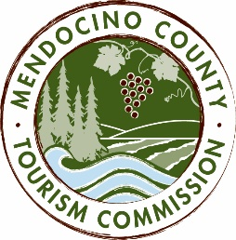
MENDOCINO COUNTY TOURISM COMMISSION, INC.
FESTIVAL COMMITTEE AGENDA
“The Festival Committee shall be composed of a maximum of seven (7) voting members as follows: (i) one (1) Director of the Corporation; (ii) six (6) members-at-large; and (iii) the Executive Director or its designee. The Festival Committee chair shall be elected by a majority of committee members. The Committee shall be responsible for advising and making recommendations to the Board in fulfilment of its duties and obligations regarding all activities, including partnerships as they relate to Visit Mendocino County festivals and events.” - bylaws, Article 6, Section 6.1, (d) (vi)

DATE: Tuesday Oct 31, 2017
TIME: 1:00PM
PLACE: Visit Mendocino County Office, 345 N Franklin St, Fort Bragg, CA 95437
CALL-IN LOCATIONS: 3766 Feliz Creek Road - Hopland, CA 95449; 7000 Highway 128, Philo, CA 95466; 110 S Franklin St, Ft Bragg, CA 95437; 390 W Standley St, Ukiah, CA 95482; 108 W Standley St, Ukiah CA 95482
Please join my meeting from your computer, tablet or smartphone.
https://global.gotomeeting.com/join/747133669
You can also dial in using your phone.
United States: +1 (571) 317-3122
Access Code: 747-133-669
*Please note: To abide by the Brown Act, call-in locations must be listed on the agenda. If anyone from the public is calling in during the meeting, it must be done at the posted locations above.
- CALL TO ORDER
- ROLL CALL
- PUBLIC COMMENT
- APPROVAL OF MINUTES
- FESTIVAL COMMITTEE RECRUITMENT
- FESTIVALS
- Mushroom Festival Update
- Crab Wine & Beer Festival: YOY, judges.
- How to best support new/upcoming festivals in our county
- FUTURE AGENDA ITEMS

NEXT MEETING DATE
1PM Tues Nov 21 (Tues before Thanksgiving) or Tues Nov 28, 2017 location TBD
ADJOURN

