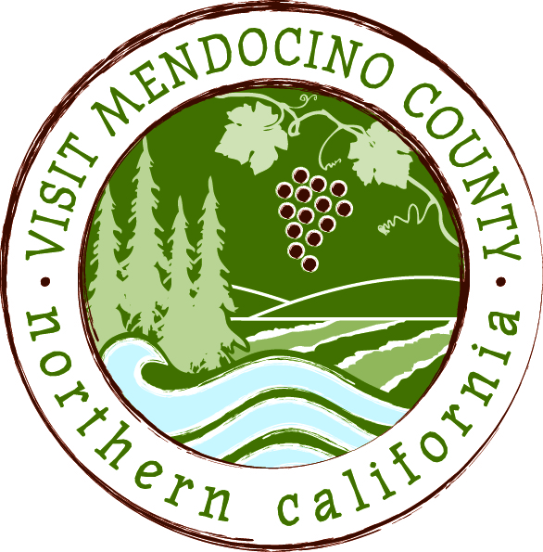

BOARD OF DIRECTOR’S AGENDA

Date: October 14, 2014 Time: 1:00 – 3:00pm
Place: Baechtel Creek Inn -Willits, CA
Dial-in Number: | 1-646-307-1300
Participant Access Code: | 694806
I. Call To Order
II. Public Comment & Introduction
III. Message of the Chair

ACTION ITEMS
IV. New Business
- Election of Officers
- Implementation of Governance Study Recommendations
- Proposed Bylaw Changes
- Quarterly Report April – June
- Quarterly Report July - September

V. Old Business:

VI. Financial Update
- 2013 - 2014 Budget Re-Cap
- 2014-2015 Budget as of 8/31/14

REPORTS
VII. Committee Updates
- Media Committee
- Festival Committee
- Visitor Services Committee
- Personnel Committee
- GMC Committee

VIII. Message of the President/CEO
- Update on Activities

IX. Partner Updates

X. Recap of Action Items

XI. Schedule Next Meeting

XII. Adjourn

