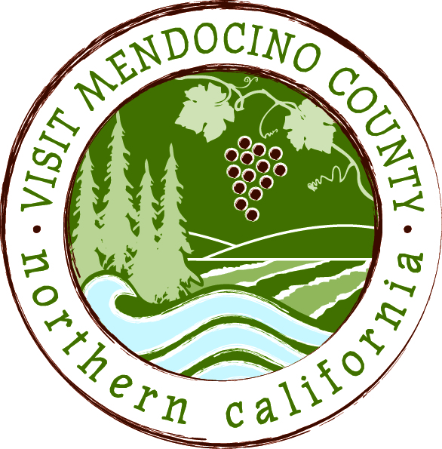

NOTICE

OF

VISIT MENDOCINO COUNTY, INC. BOARD OF DIRECTORS

SPECIAL MEETING

Date: April 13, 2015 Time: 3:00 PM
Place: Travelodge Ukiah, CA
1720 North State Street
Ukiah, California, 95482

Dial-in Number: | 1-646-475-5950
Participant Access Code: | 694806
AGENDA
- Call To Order
- Agenda Approval
- Public Comment & Introduction
- Message of the Chair
- Committee Reports.
- Ad hoc Committee re Interim General Manager position report recommending scope of work and compensation for Interim General Manager position.
- Conduct of Business
- Discussion of scope of work, compensation and appointment for the Interim General Manager position; – ACTION ITEM
VI. Adjourn

