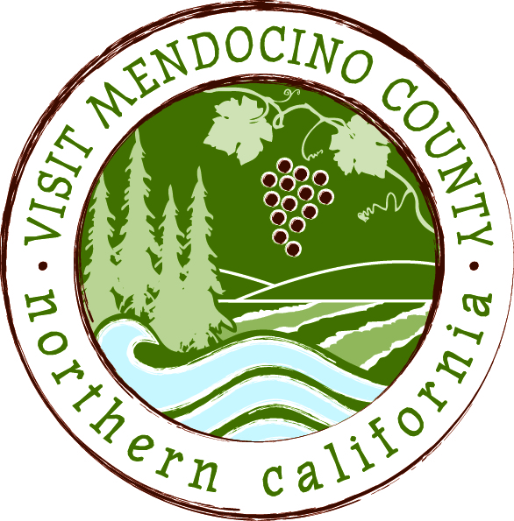

BOARD OF DIRECTOR’S AGENDA

Date: October 28, 2014 Time: 10:30AM – noon
Place: Travelodge Ukiah, Ukiah, CA
Dial-in Number: | 1-646-307-1300
Participant Access Code: | 694806
I. Call To Order
II. Public Comment & Introduction
III. Message of the Chair

III-A Closed Session
- Legal Committee Report

ACTION ITEMS
IV. New Business
- Discussion and possible action to restructure VMC Board contingent on outcome of TBID process
- Financial options for balance of fiscal year 2014/15

V. Old Business:
- Implementation of Governance Recommendations

VI. Financial Update
- 2014-2015 Budget to date

VII. Approval of Meeting Minutes from June, July and October 2014

REPORTS
VIII. Committee Updates
- Media Committee
- Festival Committee
- Visitor Services Committee
- Personnel Committee
- GMC Committee

IX. Message of the President/CEO
- Update on Activities

X. Partner Updates

XI. Recap of Action Items

XII. Schedule Next Meeting

XIII. Adjourn

