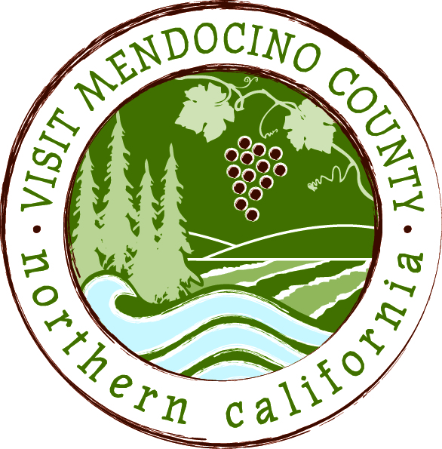

NOTICE OF

VISIT MENDOCINO COUNTY, INC. BOARD OF DIRECTORS

SPECIAL MEETING
Date: November 17, 2015 Time: 1:00pm
Place: Little River Inn
Dial-in Number: | 605-475-5950
Participant Access Code: | 694806
AGENDA
- Call To Order
- Agenda Approval
- Public Comment & Introduction
- Message of the Chair
- Open Session
- Conduct of Business.
- Adoption of Resolution changing name of corporation to Mendocino County Tourism Commission, Inc.
- Adoption of Resolution changing status of corporation from a mutual benefit corporation to a public benefit corporation
- Adoption of Resolution authorizing the filing of Amended Articles of Incorporation
- Closed Session.
- Personnel – Bylaws Section 4.3.
- Interview Candidate – Interim General Manager.
ii. Interview Candidate – Interim General Manager.
iii. Interview Candidate – Interim General Manager
- Personnel – Bylaws Section 4.3
Discussion and Appointment of Interim General Manager.
- Open Session.
- Announcement out of Closed Session. (Appointment of Interim General Manager)
- Review and Discussion of revised Bylaws.
VII. Adjourn

