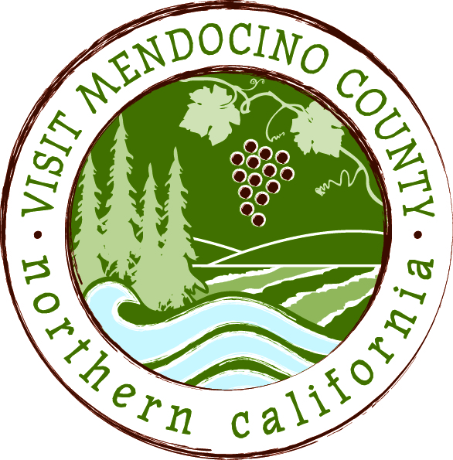

BOARD OF DIRECTOR’S AGENDA

Date: February 4, 2015 Time: 1:00 PM
Place: Travelodge Ukiah, CA
Dial-in Number: | 1-605-475-5950
Participant Access Code: | 694806
- Call To Order
- Public Comment & Introduction
- Message of the Chair
IV. REPORTS
Committee Updates (included in submitted email report)
- Media Committee
- Festival Committee
- Visitor Services Committee
- Personnel Committee
- Implementation of Governance Recommendations
  - GMC Committee
  - Supervisor ad hoc Committee – Progress report
V. ACTION ITEMS
- Approval of Meeting Minutes from October 28th and November 11th
- Financial Update - 2014-2015 Budget to date as of December 31st with proposed changes
  - Action: approve proposed changes
- October – December Quarterly Report (included in submitted email report)
  - Action: Accept report
- Officer Elections

VI. Committee Appointments – Board members are expected to serve on 1 or more committees as needed.
- Current list of seated VMC committee members and vacancies provided
- Committee assignments

VII. Message of the President/CEO
- Update on Activities (updated CEO report will be distributed)
- 2015-2016 Annual Marketing Plan and Budget Development

VIII. Partner Updates

IX. Recap of Action Items

X. Schedule Next Meeting March 4, 2015 – Coastal TBD

XI. Adjourn

