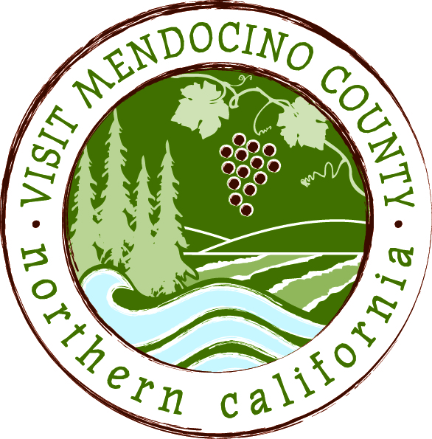

BOARD OF DIRECTOR’S AGENDA

Date: March 10, 2015 Time: 1:00 PM
Place: Harbor Lite Lodge, Fort Bragg, CA
Dial-in Number: | 1-605-475-5950
Participant Access Code: | 694806
- Call To Order
- Public Comment & Introduction
- Message of the Chair
IV. REPORTS
Committee Updates (included in submitted email report)
- Media Committee
- Festival Committee
- Visitor Services Committee
- Personnel Committee
- Implementation of Governance Recommendations
  - GMC Committee

V. ACTION ITEMS
- Approval of Meeting Minutes from February 10th
- Financial Update - 2014-2015 Budget to date as of December 31st with proposed changes
  - Action: approve proposed changes
- Committee assignments and committee chair appointments
  - Board members are expected to serve on 1 or more committees as needed.
  - Preference will be given to committee recommendations for new members per direction at last meeting.
- Supervisor ad hoc Committee – Progress report
- Action: Vote to accept ad hoc committee recommendations.
- Draft Travel and Expense Policies
  - Action: Discuss drafts and recommend next steps

VII. Message of the President/CEO
- Update on Activities (updated CEO report will be distributed)
- 2015-2016 Annual Marketing Plan and Budget Development

VIII. Partner Updates

IX. Recap of Action Items

X. Schedule Next Meeting April 14, 2015 – Coastal TBD

XI. Adjourn

