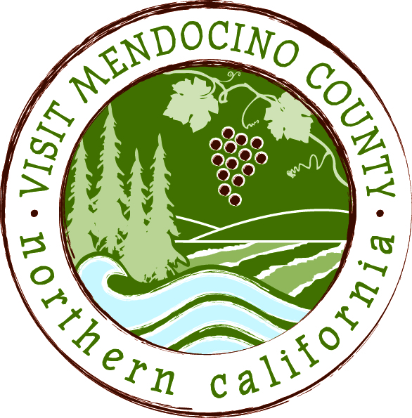

NOTICE

OF

CONTINUED

VISIT MENDOCINO COUNTY, INC. BOARD OF DIRECTORS

SPECIAL MEETING

*CLOSED SESSION*

Date: April 13, 2015 Time: 2:00 PM
Place: Travelodge Ukiah, CA
1720 North State Street
Ukiah, California, 95482

Dial-in Number: | 1-605-475-5950
Participant Access Code: | 694806
AGENDA
- Call To Order
- Public Comment & Introduction
- Message of the Chair
- Closed session

A. Personnel Matters – Bylaws Section 4.3:
Discussion of Board of Supervisors ad hoc committee recommendations for modification of termination and severance provisions of employment agreement.
Public Employee Title: President and Chief Executive Officer
B. Personnel Matters - Bylaws Section 4.3:
Approval of proposed Agreement for Modification of Agreement for Employment.
Public Employee Title: President and Chief Executive Officer
V. Announcement out of closed session

VI. Adjourn

