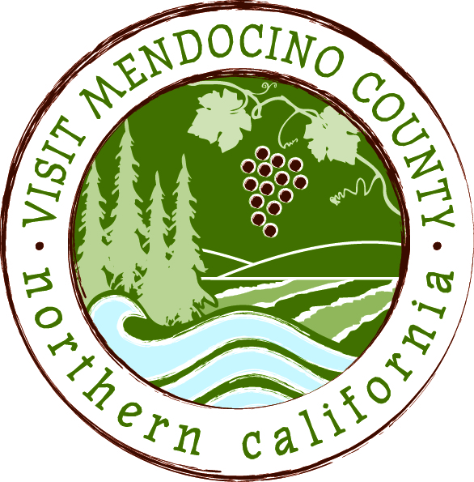

BOARD OF DIRECTOR’S AGENDA

Date: May 12, 2015 Time: 1:00 PM
Place: Fairfield Inn, Ukiah
Dial-in Number: | 1-605-475-5950
Participant Access Code: | 694806

- Call To Order
- Public Comment & Introduction
- Message of the Chair
- Approval of Minutes – March 10th and April 23rd – Action: Approve Minutes
- Financial Update
a. 2014-2015 Budget to date – Action: Approve financials
- Old Business
- Addendum 1 to the Modified Employment Agreement between VMC and Scott Schneider - Action: Approve addendum
- Organizational Name Change. Action: Possible approval of organizational name change
- Transformational process – receive ad hoc committee report - Action: approval if necessary
- MCLA/VMC contract extension- receive ad hoc report - Action: give direction as necessary
- New Business
  - VMC agreement with Neary & O’Brien - Action: Approve agreement

- Message of the President/CEO

- REPORTS
Committee Updates
- Media Committee
- Festival Committee
- Visitor Services Committee
- Personnel Committee

Schedule Next Meeting June 9, 2015 – Coastal TBD

Adjourn

