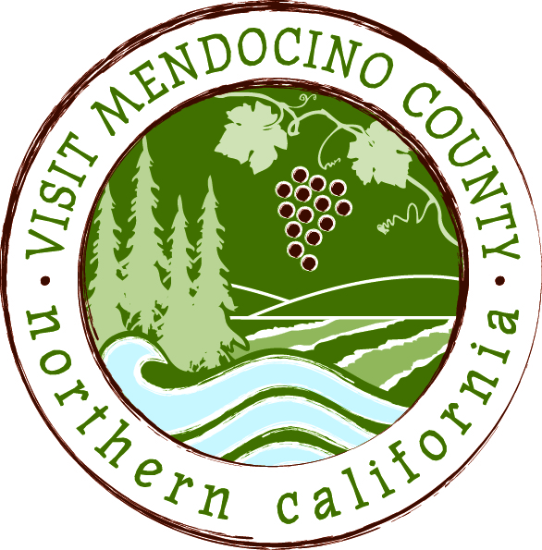

BOARD OF DIRECTOR’S AGENDA

Date: June 23, 2015 Time: 1:00 PM
Place: Harbor Lite Lodge, Fort Bragg
Dial-in Number: | 1-605-475-5950
Participant Access Code: | 694806

- Call To Order
- Public Comment & Introduction
- Message of the Chair
- Approval of Minutes – May 12th – Action: Approve Minutes
- Financial Update
a. 2014-2015 Budget to date – Action: Approve financials
- Old Business
- Transformational process – receive ad hoc committee report - Action: approval if necessary
- New Business
  - Adjust Marketing Plan and Budget dependent on partial BID renewal – Action: Approval if necessary
  - Procedure for Board members obtaining financial information – Action: approval if necessary
- Message of the President/CEO

- REPORTS
Committee Updates
- Media Committee
- Festival Committee
- Visitor Services Committee
- Personnel Committee

Schedule Next Meeting July 14, 2015 – Coastal TBD

Adjourn

