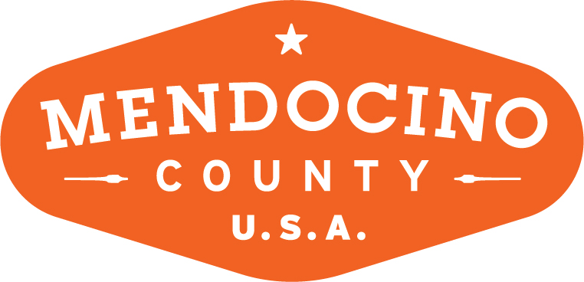

MENDOCINO COUNTY TOURISM COMMISSION, INC.
BOARD OF DIRECTORS MEETING MINUTES

DATE: Thursday, May 3, 2018 TIME: 10:30am
PLACE: 444 N. Main Street, Fort Bragg, CA
CALL-IN LOCATIONS: None

*Please note: To abide by the Brown Act, call-in locations must be listed on the agenda. If anyone from the public is calling in during the meeting, it must be done at the posted locations above.

I. CALL TO ORDER
10:40am meeting was called to order by Member Kuhry.

II. ROLL CALL
Members Kuhry, Ishwar, Dym, Seward, Byrne, Bradley, Ariosta, Davis and IED Cooper.

III. CHAIR’S COMMENTS
None

IV. PUBLIC COMMENT ON NON-AGENDA ITEMS
Member Dym requested to add an emergency item to the agenda regarding a possible recommendation to add language to the BID Annual Report. Motion by Cally, seconded by Byrne.
Motion passed 8-0

V. CONSENT AGENDA ITEMS
The Consent Agenda is considered routine and non-controversial and will be acted upon by the MCTC Board at one time without discussion. Any MCTC Board member may request that any item be removed from the Consent Agenda for individual consideration.

a. Minutes from the 4/10/18 meeting
b. MCTC Financials from 3/18

Motion by Dym, seconded by Ishwar.
Motion passed 8-0.

VI. DISCUSSION OF POSSIBLE ADDITION TO THE ANNUAL BID REPORT
Member Dym reported that the County wants to see cannabis tourism promoted. Supervisor John McCowen has asked that more specific language be added to the Annual BID Report. Member Dym motion to add the following language- “MCTC continues to be interested in reviewing options for legal cannabis tourism promotion.” Member Byrne seconded.
Motion Failed 2-5 with Member Bradley abstaining.

VII. UPDATES AND BOARD CHECK-IN
None.

VIII. 10:53
Member Kuhry called for Closed Session to interview Executive Director Candidates.

IX. FUTURE AGENDA ITEMS
None.

X. NEXT MEETING
Tuesday, June 12, 2018.

XI. ADJOURN
3:17 Member Dym moved to adjourn.

