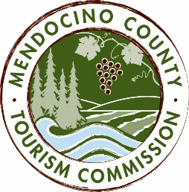

MENDOCINO COUNTY TOURISM COMMISSION, INC.
FESTIVAL COMMITTEE AGENDA

DATE: Wednesday, February 24, 2016
TIME: 10:30 am
PLACE: Visit Mendocino County, 390 W. Standley St., Ukiah CA 95482
CALL-IN LOCATION: Little River Inn, 7901 Highway One, Little River, CA 95456
CALL-IN LOCATION: KOZT Radio, 110 S. Franklin St, Fort Bragg, CA 95437
CALL-IN NUMBER: 1-605-475-5950 Passcode: 5341706

- CALL TO ORDER
- ROLL CALL
- PUBLIC COMMENT
- FESTIVAL COMMITTEE MEETING POLICIES
- FESTIVAL COMMITTEE ADDITIONAL FUNDS AND PLANS
- MARKETING PLAN 2016/17 (http://mendocinotourism.org/wp-content/uploads/2015-16-VMC-Marketing-Plan.pdf
- REBRANDING
- MUSHROOM FESTIVAL SURVEY
- CRAB FESTIVAL SURVEY
- PARTY FOR THE PLANET

NEXT MEETING DATE

ADJOURN

