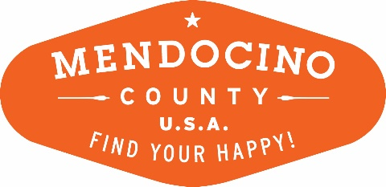
MENDOCINO COUNTY TOURISM COMMISSION, INC.
Finance Committee Agenda DATE: Wednesday, August 29, 2018 TIME: 11:00 AM
PLACE: 105 W. Clay Street Ukiah CA 95482
CALL-IN: Redwood Empire Fair Grounds, 1055 N State St, Ukiah, CA 95482
*Please note: To abide by the Brown Act, call-in locations must be listed on the agenda. If anyone from the public is calling in during the meeting, it must be done at the posted locations above.
I. CALL TO ORDER
II. ROLL CALL:
III. CHAIR’S COMMENTS
IV. PUBLIC COMMENT ON NON-AGENDA ITEMS
Brown Act Requirements: Pursuant to the Brown Act, the Board cannot discuss issues or take action on any requests during the comment period.
V. REVIEW July Credit Card Statement
VI. REVIEW CURRENT STAFF & CONTRACTOR REIMBURSEMENTS
VII. REVIEW AND POSSIBLE ACTION TO APPROVE July 2018 Financial statements
VIII. SET NEXT MEETING
X. ADJOURN

