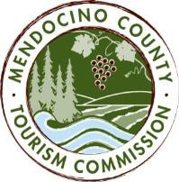

MENDOCINO COUNTY TOURISM COMMISSION, INC. MARKETING COMMITTEE AGENDA

DATE: Wednesday July 5, 2017 TIME: 11:00AM
LOCATION: Visit Mendocino County, 390 W. Standley St, Ukiah CA 95482

CALL-IN: Dial-in Number: United States (712) 770-4700
Access Code: 713704

*Please note: In accordance with the Brown Act, call-in locations must be listed on the agenda. If anyone from the public is calling in during the meeting, it must be done from or at the locations above.
- CALL TO ORDER
- ROLL CALL
- PUBLIC COMMENT –Pursuant to the Brown Act, the Committee cannot discuss issues or take action on any requests during the comment period
- APPROVE MINUTES: JUNE 16, 2017
- THEORYSF
ACTION ITEM: RECOMMEND RETENTION OF THEORYSF TO THE MCTC BOARD FOR FISCAL YEAR 2017/18 FOR BRANDING, MARKETING, WEBSITE
- THEORYSF: UPDATE ON PLATFORM RESEARCH
- MARKETING PROGRAMS: FAMILY TRAVEL WITH COLLEEN KELLY; BAY AREA LIFE
- NEW SOCIAL MEDIA CONTRACTOR
- MARKETING COMMITTEE MEMBERS

NEXT MEETING DATE

ADJOURN

