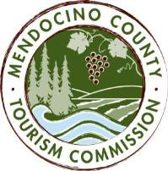

MENDOCINO COUNTY TOURISM COMMISSION, INC. MARKETING COMMITTEE AGENDA

DATE: Wednesday November 8, 2017 TIME: 11:00AM
LOCATION: Visit Mendocino County, 390 W. Standley St, Ukiah CA 95482

CALL-IN: Visit Mendocino County, 345 N. Franklin St, Fort Bragg, CA 95437
101 Gregory Lane, Willits CA 95490
Please join my meeting from your computer, tablet or smartphone.
https://global.gotomeeting.com/join/257942589
You can also dial in using your phone.
United States: +1 (224) 501-3412; Access Code: 257-942-589

*Please note: In accordance with the Brown Act, call-in locations must be listed on the agenda. If anyone from the public is calling in during the meeting, it must be done from or at the locations above.
- CALL TO ORDER
- ROLL CALL
- PUBLIC COMMENT –Pursuant to the Brown Act, the Committee cannot discuss issues or take action on any requests during the comment period
- APPROVE MINUTES: October 4, 2017
- THEORYSF:
  - WEBSITE PROGRESS UPDATE
  - MUSHROOM, WINE & BEER FESTIVAL MARKETING PROMOTION TO DATE
- DATA DASHBOARD

NEXT MEETING DATE

ADJOURN

