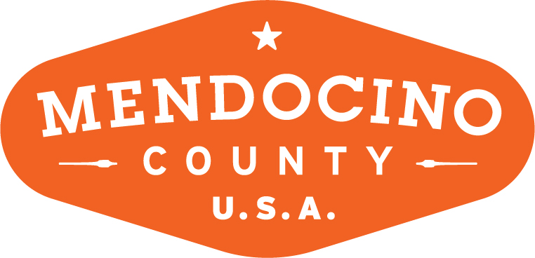

MENDOCINO COUNTY TOURISM COMMISSION, INC.
MARKETING COMMITTEE MINUTES

DATE: Wednesday May 2, 2018 TIME: 11:00AM
LOCATION: Visit Mendocino County, 345 N. Franklin St, Fort Bragg, CA 95437

*Please note: In accordance with the Brown Act, call-in locations must be listed on the agenda. If anyone from the public is calling in during the meeting, it must be done from or at the locations above.
- CALL TO ORDER
11:10AM
- ROLL CALL
Susie Plocher, Wendy Roberts, Bernadette Byrne, Richard Cooper, Alison de Grassi, Richard Strom
- PUBLIC COMMENT –Pursuant to the Brown Act, the Committee cannot discuss issues or take action on any requests during the comment period
NONE
- APPROVE MINUTES: April 4, 2018
TABLED DUE TO LACK OF FORUM
- THEORYSF:
  - INTERNAL STAKEHOLDER BRAND LAUNCH EDUCATION SESSIONS
Alison updated the committee on the meetings held for stakeholders in Ukiah and Fort Bragg. Overall the meetings were a great success and VMC has some follow-up items to distribute to stakeholders. All agreed that holding these types of meetings on a regular basis will go a long way to keeping relations smooth between VMC and stakeholders.
  - WEBSITE UPDATE
The website is set to launch on Tuesday May 8. The team is working hard to continue updates and review checklists.
  - MARKETING OUTLINE FOR FY 2018/19
TheorySF has submitted their proposed Scope of Work for 2018/19. Alison is working on the Marketing Plan and will incorporate their topics as part of the plan.
  - "HOW TO MENDO" FILM SHOOT
The social media film shoot happened at the end of April. It was very successful and the team captured 10 How to Mendocino moments. The footage is in for editing. Alison will coordinate with TSF and Brendan over release dates.
- MARKETING PLAN FOR 2018/19 FY
Alison is working on the plan and will have a draft for the Board to approve at their June meeting.
- MUSHROOM FESTIVAL – UPDATE IDEAS/SUGGESTIONS
All agree the festival needs a facelift and a brainstorming session with the committee produced the “Farming and Foraging Festival.” Wendy suggested a map with destinations where mushrooms are located. Perhaps outreach to other organizations /publications will attract a different audience. Alison will follow up with TSF.
NEXT MEETING DATE
June 6, 2018 at 11AM in Ukiah
ADJOURN
11:50AM

