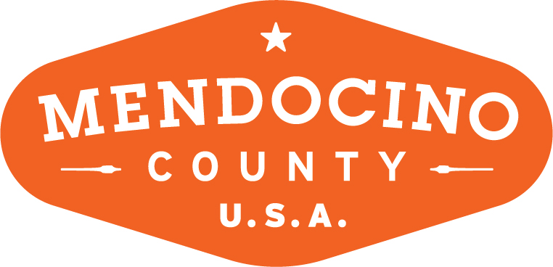

Mendocino Complex Fire Response

On July 27, 2018 two fires broke out within an hour of each other: the River Fire on Old River Road south of Ukiah and the Ranch Fire on Highway 20.

July 30: The PR team (Director of Marketing & Media and Koleen Hamblin/KOLI Communications) proactively prepared a series of stakeholder and website messaging points in the event the fire grew. The same date, the Visit CA Public Affairs Manager contacted the VMC PR team to convey the information that VCA was also closely monitoring the situation.

August 2: The PR team and VMC ED made the decision to send the first of three emails to stakeholders and partners about the fire situation. The following day (August 3) as the complex grew in intensity, the team posted a notice on the VMC website alerting visitors that the fire was not affecting tourist destinations and posting links to information resources: Cal Fire, Cal Trans, air quality, and a current map of the complex. The team also informed county Chambers of Commerce of their actions and forwarded VMC’s messaging.

August 6: The team sent a second email to stakeholders with updated information and steps taken: industry outreach and messaging; visitor relations messaging on website and social media; stakeholder outreach; media relations; and preparation of media materials. Also on August 6, the PR team spoke with Visit California and requested their assistance with social media messaging as their reach is much greater than that of VMC. VCA requested 5 or 6 FB posts with messaging and images, which the PR team supplied on August 7. To date, VCA has not posted anything on their social media outlets.

August 7: The PR team updated the messaging on the website stressing that no tourism facilities are affected by the fire and emphasizing that the county was open for business.

August 8: PR team prepared and released a national press release for Business Wire with the headline “COAST IS CLEAR IN MENDOCINO COUNTY; WILDFIRES REMAIN IN REMOTE WILDERNESS REGIONS; ALL MAJOR HIGHWAYS & TOURISM FACILITIES OPEN.” The PR team continues to respnd to media inquiries regarding the release.

Also, the third stakeholder email was issued complete with top talking points and verbiage for stakeholders to use on their own websites and outreach.

Outreach to Visit CA PR team and their PR agency of record to schedule a phone meeting to determine the best strategy and next steps to address the Mendocino Complex Fire and misinformation that currently exists. The VCA response was that they were unavailable due to being involved with Visit California’s Highway 1 ‘Dream Drive’ activation. Bote: the PR team is underwhelmed by VCA’s lack of response.

August 9: Updated website to reflect current knowledge, resources, and “open for business” messaging.
August 10: SF Travel is proactively assisting Mendocino County in providing visitor resources and including the Mendocino County messaging. The PR team will continue to closely monitor the situation and provide updates to visitors and stakeholders as appropriate.

