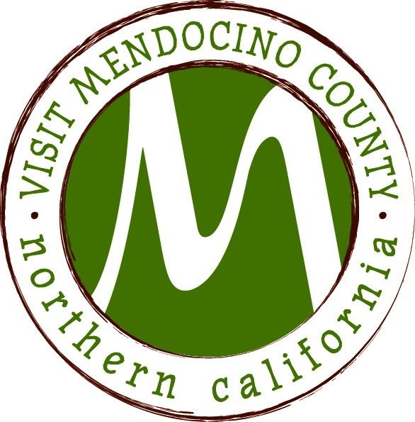

Minutes
Date: October 28, 2014 Time: 1:00 – 3:00pm
Place: Travelodge Ukiah
Dial In #: 646-307-1300 Passcode: 694806#

Present: Glenna Blake, Cally Dym, Hal Wagenet, Janis MacDonald, John Kuhry
Phone:
Staff: Erin Placido, Scott Schneider
Guests: Jitu Iswar
I. Call To Order
Hal Wagenet called the meeting to order at 10:42am
II. Public Comment & Introduction
III. Message of the Chair
“When seeking revenge, dig 2 graves”

III A. Closed Session
- Legal Committee Report
Hal closed the meeting for closed session
Board heard a report from the legal committee and gave direction to the chair to send a letter of response to John Dixon’s letter from MCLA dated October 2nd

ACTION ITEMS – Meeting reopened at 11:54
IV. New Business
- Discussion and possible action to restructure VMC Board contingent on outcome of TBID process
tabled
- Financial options for balance of fiscal year 2014/15
Board discussed any actions that need to take place in order to continue. Plan is to continue with working capital through Christmas time. VMC is continuing to move forward and no contracts are being cancelled

V. Old Business:
a. Implementation of Governance Recommendations
No information currently available to move forward. However, November 4th is the date for the modified BID to go before the BOS. December 2nd is the final hearing. Both meetings before the BOS will take place at 9am.

VI. Financial Update
- 2014-2015 Budget to date
Glenna Blake moves to accept the financial report. Cally Dym seconds. Motion passed unanimously

VII. Approval of Meeting Minutes from June, July, October 2014
John Kuhry moves to approve the minutes from the June meeting. Glenna Blake seconds. Motion passed unanimously

Janis MacDonald moves to approve the minutes from the July meeting. Cally Dym seconds. Motion passed unanimously.

Corrections to Oct: Cally Dym was a Board member, Jeff was there as a guest. Glenna Blake moves to approve October minutes as discussed. Cally Dym seconds. Board wishes to add addendum of John Dixon’s email to the minutes. Motion passed unanimously.

REPORTS
VII. Committee Updates
- Media Committee
- Festival Committee
- Visitor Services Committee
- Personnel Committee
- GMC Committee
Board discussed postponing changes in committee appointments until the TBID process is complete.
VIII. Message of the President/CEO
- Update on Activities – Mushroom festival is ready to go – many events close to being sold out; Crab festival brochure is almost complete; 2015 visitor guide put on a temporary hold. Printing is expected in January
- See attached monthly CEO report

IX. Partner Updates

X. Recap of Action Items

XI. Schedule Next Meeting
Next meeting will be Coastal on November 11 at 1pm at the VMC offices in Fort Bragg.

XII. Adjourn – Cally moves to adjourn at 12:11

OCTOBER RECAP 2014 VMC PRESIDENT/CEO MONTHLY REPORT
Marketing/PR/Advertising
PR Highlights Decanter Magazine San Jose Mercury News Sonoma Magazine Sacramento Magazine Bend Bulletin
Working on itineraries for upcoming visits
Secured guests for Rudy Maxa's World live radio remote
Press release re: Mushroom, Wine & Beer Festival
Secured three judges for Mushroom, Wine & Beer Festival
Issued media materials to 1,039 media outlets
Continued marketing efforts with heavy online banner ads, outdoor billboards and radio ads. Traffic and conversion rates were above average
Attended Visit California’s 1st ever Boulder, Colorado media event focusing on outdoor adventure. Future visits by media to our county have been already secured for next year
Completed 2 days of media appointments in Los Angeles including LA Times, several freelancers and Outside Magazine. 3-4 media visits are being worked on for the coming months
Events
Distributed brochures and signage for the Mushroom, Wine & Beer Festival happening county-wide November 7-16
Wrapping up edits on the Crab, Wine & Beer Festival brochure to send off to the designer happening county-wide January 16-25, 2015
Local events are now posted online at www.VisitMendocino.com
Administration
 Began work on the 2015 Official County Visitor Guide. If you are interested in advertising in this year’s award winning guide, please email Gracia@VisitMendocino.com
The 3rd annual VMC wall calendar is complete and will be headed to the printer in the coming weeks. Distribution and sales will begin the end of November
Researched and developed regional bi-monthly calendars providing information on upcoming events for use in businesses county-wide
Attended Visit California workshop discussing future promotional, marketing and website activities for 2015 and beyond
Sales & Visitor Services
Visitor Services
 Completed Mendocino County Pet-Friendly brochure, available now as a pdf on the website and hard copies available soon
Sales
 Attended AARP trade show in San Diego
Attended Bark in the Park pet show in San Jose
Prepared for Sales missions to Toronto and New York in October
Japanese Tour Operator notified VMC they have an upcoming group tour package to Mendocino County; directly due to Japanese FAM earlier this summer
British Tour Operator notified VMC of an upcoming website-featured travel package to Mendocino County due directly to sales efforts

Facebook Fans = 31,191
Featured Articles: 19
Ad Equivalency: $155,295
Media Secured/Hosted: 5
Marketplace Visitors YTD = 3,952
Monthly Marketing/PR Tip :'Word of mouth"' is one of the cheapest and most effective forms of promotion. Providing excellent customer service and an extraordinary experience for the visitor is so important - both satisfied and unsatisfied customers will tell others about your product or service.

