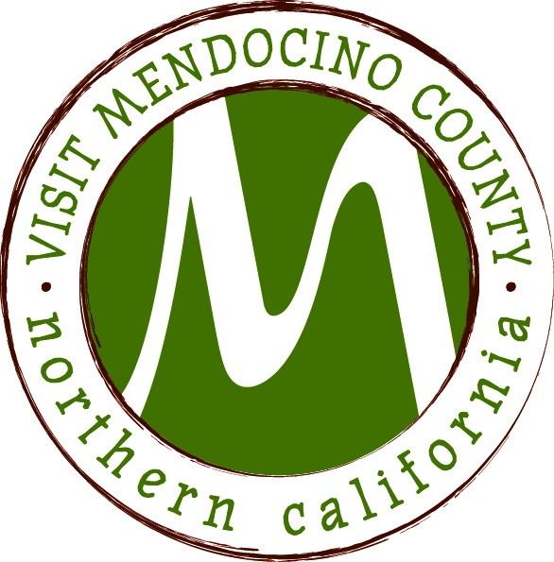

Minutes
Date: April 13, 2015 Time: 2:00 – 4:00pm
Place: Redwood Empire Fairgrounds, Ukiah, CA
Dial In #: 605-475-5950 Passcode: 694806#

Present: Hal Wagenet, Jennifer Seward, Cally Dym, John Kuhry, Roger Martin, John Dixon
Phone :
Staff: Scott Schneider,
Guests: Jennifer O’brien
I. Call To Order
Hal called the meeting to order at 2:14
Jennifer O’brien, legal council, announced that the board members would meet in closed session regarding personnel matters noted below.
II. Public Comment & Introduction
none given
III. Message of the Chair
none given
IV. Closed Session
The board went into close session at 2:15 to discuss
Personnel Matters
- Personnel Matters – Bylaws Section 4.3:
Discussion of Board of Supervisors ad hoc committee recommendations for modification of termination and severance provisions of employment agreement.
Public Employee Title: President and Chief Executive Officer
- Personnel Matters - Bylaws Section 4.3:
Approval of proposed Agreement for Modification of Agreement for Employment.
Public Employee Title: President and Chief Executive Officer
VI. Announcement out of Closed Session
Board returned from closed session at 4:09 pm and Jennifer O’Brien, legal council, reported out:
The board met pursuant to bylaw section 4.3. As noted above:
No action was taken.
Meeting will take place on April 23 at 1pm at a coastal location to be determined
VII. Schedule next meeting – April 14th Inland Baechtel Creek Inn, Willits, CA
VIII. Adjourn at 4:10pm

