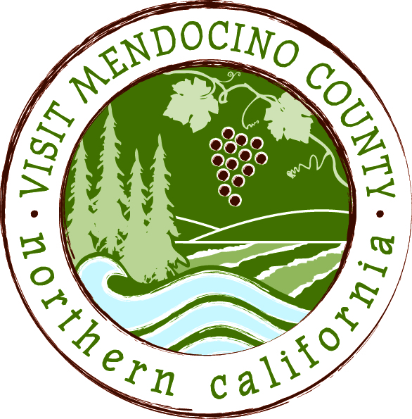

BOARD OF DIRECTOR’S MINUTES

Date: May 12, 2015 Time: 1:00 PM
Place: Fairfield Inn, Ukiah, CA
Dial-in Number: | 1-605-475-5950
Participant Access Code: | 694806

Attendees: Marcus Magdaleno, Hal Wagenet, Jennifer Seward
Phone: Cally Dym, Tom Rodrigues, John Dixon, Roger Martin
Staff: Erin Placido, Scott Schneider
Guests: Jennifer O’Brien, Jan Rodriguez, John McCowen
- Call To Order
Hal Wagenet called the meeting to order at 1:08pm
- Public Comment & Introduction
none given
- Message of the Chair
none given
- Approval of Minutes – March 10th and April 23rd
Jennifer Seward moves to approve the minutes from March 10th and April 23rd. Cally Dym seconds. Motion passed unanimously.

- Financial Update
- 2014-2015 Budget to date
Scott provided an update that everything is within range and nothing is projected to go over budget.
Jennifer Seward moves to approve the financial update. Marcus Magdaleno seconds. Motion passed unanimously.

- Old Business
- Addendum 1 to the Modified Employment Agreement between VMC and Scott Schneider
Jennifer O’Brien read the addendum that was included in the board packet.
John Dixon moves to accept the addendum as presented. Tom Rodrigues seconds. Motion passed unanimously.

- Organizational Name Change
Options discussed:
Mendocino County Tourism Council
Mendocino County Tourism Commission (winner)
Mendocino County Visitor Bureau
Mendocino County Travel Association
Mendocino County Tourism Association
Mendocino County Tourism Board

Jennifer Seward moves to approve the name Mendocino County Tourism Commission. Tom Rodrigues seconds. Motion passed unanimously.

- Transformational process
The ad hoc made up of Hal Wagenet and John Dixon reported out. Hal Wagenet read the recommended verbiage.
See Page 3

- MCLA/VMC contract extension
Jennifer O’Brien to craft new language to include a clearer notion of dissolution of VMC or if the County appoints a new contractor to handle district services.

Add to Section 1 a reference to Exhibit A of the Agreement between the County and MCLA (the services) [and renumber other exhibits] - my recollection is that the approval was of the reference, not to specific language
Changed language: added:
The first sentence of the first paragraph of Section 1.A. shall be amended as follows:
“VMC shall market Mendocino County (County) and Mendocino County lodging properties and administer District services as provided in Exhibit “A” hereto. VMC shall perform all services to be performed by “Contractor” in Exhibit A hereto.”
In Paragraph 1.A., add “as defined in Exhibit A hereto”
Add the following language to paragraph 4 (amending Paragraph 1.O of the Agreement) [addition of bolded language approved]:
“O. In the event VMC dissolves, or Mendocino County appoints a successor entity to administer the Mendocino County BID Marketing Plan, after payment of its outstanding liabilities, VMC shall transfer all of its material and financial assets to any such successor agency authorized to implement the approved Mendocino County BID Marketing Plan. Any transfer of VMC assets is subject to approval of the California Attorney General pursuant to California Corporations Code § 7913.”
Jennifer Seward moves to accept the contract extension agreement that was first discussed which includes two changes in verbiage noted above. Marcus Magdaleno seconds. Motion passed unanimously.

VII. New Business
- VMC agreement with Neary & O’brien
Hal presented the service agreement that was included in the Board packet.

Marcus Magdaleno moves to approve the agreement for legal services. Tom Rodrigues seconds. Motion passed unanimously.

VIII. Message of the President/CEO
See report page 5

IX. Reports
Wine– Featured on an ABC TV show “Days of Sirah”. Both Tom and Cally’s businesses were featured. American Airlines inflight video in the works for October/November on 5,600 AA flights.

Festival Committee: Met last month to discuss Party for the Planet and Mushroom Festival. It looks like the venue for the mushroom fest is no longer available. Possibly the Boonville Fairgrounds or at Camp Navarro as an alternates. Discussion on cannabis in Mendocino County and having a festival in 2017.

Schedule Next Meeting – June 9, 2015 – Coastal TBD

Adjourn
Meeting adjourned at 2:45 pm

