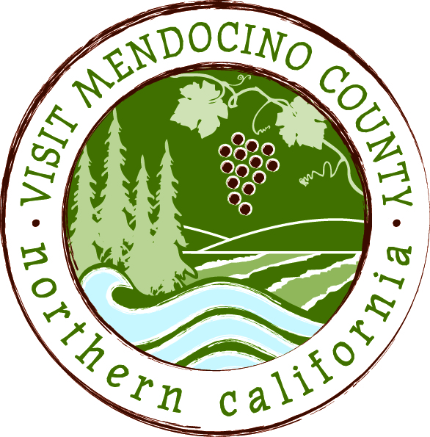

BOARD OF DIRECTOR’S MINUTES

Date: September 8, 2015 Time: 1:00 PM
Place: Point Noyo, Fort Bragg, CA
Dial-in Number: | 1-605-475-5950
Participant Access Code: | 694806
Attendees: Cally Dym, Hal Wagenet, John Dixon
Phone: Eric Cogdill, Marcus Magdaleno, John Kuhry, Jennifer Seward, Margaret Pedroni
Staff: Erin Placido, Scott Schneider
Guests: Jason Hurst
- Call To Order
Hal Wagenet called the meeting to order at 1:02pm
- Public Comment & Introduction
None given
- Message of the Chair
“Let’s get to it”
- Conduct of Business

- Approval of Minutes: 8/11/15
Cally moves to approve the minutes from 8/11/15. John Dixon seconds. Motion passed unanimously

- Financial Update
- 2014-2015 Budget as of July 31st
John Kuhry provided an overview on the financials as of July 31st.
The board discussed having budget reporting be monthly versus cumulative. Board wishes to have the “comments” section included at all times.

Margaret Pedroni moves to approve the financial report as presented. Hal Wagenet seconds. Motion passed with 7 ayes and 1 nay.
Eric Cogdill– yes
Marcus Magdaleno– yes
Cally Dym – yes
John Dixon – no
John Kuhry – yes
Jennifer Seward – yes
Margaret Pedroni – yes
Hal Wagenet – yes.

Board discussed having the personnel line items being allocated regularly to each category. Staff would be required to keep track of time spent working in each category.

Cally moves to remove the “personnel cost” line item on each category noted on the current budget until the new governing board has taken over. John Kuhry seconds. Motion passed with 5 yes and 3 no
Eric Cogdill – no
Marcus Magdaleno – no
Cally Dym – yes
John Dixon – no
John Kuhry – yes
Jennifer Seward – yes
Margaret Pedroni – yes
Hal Wagenet – yes

Marcus moves that staff report out at the next meeting what they (staff) believe the effort (time and costs) would be to measure their time according to each personnel category as noted on the budget and as discussed earlier.
Eric Cogdill – yes
Marcus Magdaleno – yes
Cally Dym – yes
John Dixon – yes
John Kuhry – yes
Jennifer Seward – yes
Margaret Pedroni – yes
Hal Wagenet - yes

- Old Business
- BID Ad Hoc Committee Update
The committee has not met

- Bylaws Ad Hoc Committee Update
The board discussed the draft bylaws that were included in the packet for today’s meeting.

Board to run questions raised today through legal prior to next Board meeting.

Hal presented the report out from legal as was requested at the August meeting. Erin to scan and sent to those on the phone.

- VMC/MCTC Transition
Board discussed the “MCTC Transition” document that was submitted as a part of the board packet

- MCLA update on VMC ED Job Description
MCLA met last week. This task has been abandoned

- Committee Updates
- Media Committee –
Committee met this morning. Did not have a quorum to approve Dog Trekker. Did view the status of the website transfer from Drupal to WordPress. Will be launched this week. Also viewed video’s that are being produced.
- Festival Committee –
Margaret gave an update regarding the concern surrounding the merging of the Visitor Services and Festival Committee’s. Have issues with the County Museum as it relates to committing to Camp Navarro as the location for the Mushroom Festival signature event. Board discussed getting the County involved. Board discussed the lack of interest in the Mushroom festival from the beer community. Hal to meet with Margaret and Alison to inform the County of the decision
- Visitor Services Committee –
Marcus reported that the committee has nothing to report
- Personnel Committee –
Hal will convene a meeting in the coming weeks to put an interim contract in place

- New Business
- Operations Manual
Board discussed reading the manual and providing feedback prior to the next Board meeting
- Message of the Executive Director
See monthly report page 8

- Partner Updates
MCLA met last week. Re-approved the MCLA/County Contract with the changes that MCPA had changed in order to maintain consistency. Board moved to approve giving John Dixon approval to use the list serve as a place to suggest lodging members participate in the election process for the new governing board. Board officially approved the continued funding of the Arts Council funding until the new board is seated.
John Dixon reported on the email that Hal sent encouraging the County to support those nominees who might support the 2% BID. John McCowen stated that is not a prerequisite for election.

MCPA has not yet met. Will meet in October. Funding from the County is up 8% over budget

Arts Council – Hal will report to Council of the funding status

Wine – Harvest is 1/3 lower than previous years. Quality is constantly high. Meetings are taking place in the future regarding Taste of Mendocino. May go back to being trade only and at a new location

- Recap of Action Items

- Schedule Next Meeting – October13 - Inland TBD

- Adjourn – Cally moves to adjourn at 3:14pm

