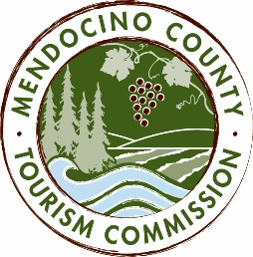

MENDOCINO COUNTY TOURISM COMMISSION, INC.
MARKETING COMMITTEE AGENDA

DATE: Friday, February 19, 2016
TIME: 10:00am
PLACE: Visit Mendocino County, 390 W. Standley St., Ukiah CA 95482
Abalone Room, Little River Inn, 7901 Highway One, Little River, CA 95456
1319 Robbins St., Santa Barbara CA 93101
CALL-IN: 641-715-3274; ACCESS CODE: 1024909#
GUEST: Koleen Hamblin, Koli Communications

- CALL TO ORDER
- ROLL CALL
- CHAIR’S COMMENTS
- MARKETING COMMITTEE MEETING POLICIES
- PR AND ADVERTISING ADDITIONAL FUNDS AND PLANS
- WEBSITE AND SOCIAL MEDIA ADDITIONAL FUNDS AND PLANS
- VISIT CALIFORNIA CO-OP
- MARKETING PLAN 2016/17 (http://mendocinotourism.org/wp-content/uploads/2015-16-VMC-Marketing-Plan.pdf
- REBRANDING

NEXT MEETING DATE
ADJOURN

