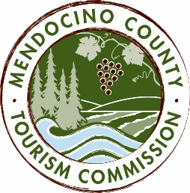

MENDOCINO COUNTY TOURISM COMMISSION, INC.
MARKETING COMMITTEE AGENDA

DATE: Wednesday March 16, 2016
TIME: 2:00PM
PLACE: Visit Mendocino County, 390 W. Standley St., Ukiah CA 95482
Visit Mendocino County, 345 N. Franklin St., Fort Bragg CA 95437
Little River Inn, 7901 Highway One, Little River, CA 95456
Mendocino Community Network, Internet Service Provider, e10700 Ford St, Mendocino, CA 95460
CALL-IN: 641-715-3274; ACCESS CODE: 1024909#

- CALL TO ORDER
- ROLL CALL
- CHAIR’S COMMENTS
- PUBLIC COMMENT - Brown Act Requirements: Pursuant to the Brown Act, the Committee cannot discuss issues or take action on any requests during the comment period
- APPROVAL OF MINUTES FROM FEBRUARY 19, 2016 MEETING
- OLD BUSINESS
  - Advertising Campaign for remainder of FY 2015/16
- NEW BUSINESS
  - Discussion Items:
    - Advertising Plan FY 2016/17
      - http://pulsepointdemo.com/view/mail?iID=GFtLdkZn5kn6f2jLK65n
      - Weekend Sherpa program
      - Outdoors Co-op with Visit CA
      - Photographers: Brian Klonoski in March; Photo Safari in April
    - PR Proposal FY 2016/17
    - Videographer: Jay Watson: http://jay.gprojectgear.com
    - Rebranding
  - Action Items:
    - Community Communications Plan
    - Social Media Consultant FY 2016/17

NEXT MEETING DATE
ADJOURN

