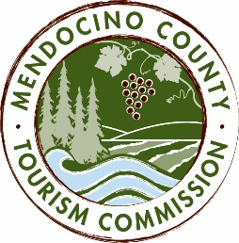

MENDOCINO COUNTY TOURISM COMMISSION, INC.
MARKETING COMMITTEE AGENDA

DATE: Tuesday April 19, 2016
TIME: 10:00AM
PLACE: Visit Mendocino County, 345 N. Franklin St., Fort Bragg CA 95437
Visit Mendocino County, 390 W. Standley St., Ukiah CA 95482
CALL-IN: 641-715-3274; ACCESS CODE: 1024909#
GUESTS:
Time, Inc.: John Godfrey, Christina Kornrich, Melissa Rann
DCI: Daniel Guerrero

- CALL TO ORDER
- ROLL CALL
- CHAIR’S COMMENTS
- PUBLIC COMMENT - Brown Act Requirements: Pursuant to the Brown Act, the Committee cannot discuss issues or take action on any requests during the comment period
- APPROVAL OF MINUTES FROM MARCH 16, 2016 MEETING
- OLD BUSINESS
  - Weekend Sherpa program (newsletter and website program)
  - Photographers: Brian Klonoski in March; Photo safari in April
  - Community Communication Update
- NEW BUSINESS
  - DISCUSSION ITEMS:
    - Frommer's ad proposal
    - Time Inc./Visit California: call-in and walk through proposal (10:30AM)
    - DCI California Collective: call-in and walk through proposal (11:00AM)
    - Meltwater - alternative clipping service
    - Burrelle's/Luce clipping service contract
    - Visit Mendocino County "game plan" – proposal by Brendan McGuigan for the development of a game App featuring Mendocino County
PowerPoint version:
https://mctc.box.com/s/d4qr7dm4umontbgaivekg4dsa0ghfu8i
PDF version:
https://mctc.box.com/s/6417p992stnwx8gdy3sglcufcabbd9mw
    - 2016/17 budget items
  - ACTION ITEMS:

NEXT MEETING DATE
ADJOURN

