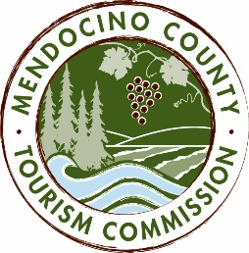

MENDOCINO COUNTY TOURISM COMMISSION, INC.
MARKETING COMMITTEE AGENDA
“The Marketing Committee shall be composed of a maximum of seven (7) voting members as follows: (i) one (1) Director of the Corporation; (ii) six (6) members-at-large; and (iii) the Executive Director or its designee. The Marketing Committee chair shall be elected by a majority of committee members. The Committee shall be responsible for advising and making recommendations to the Board in fulfilment of its duties and obligations regarding all marketing activities and issues, including but not limited to advertising, public relations and website activites.” - bylaws, Article 6, Section 6.1, (d) (iv)

DATE: Wednesday June 8, 2016
TIME: 3:00PM
PLACE: Visit Mendocino County, 390 W. Standley St., Ukiah CA 95482
Visit Mendocino County, 345 N. Franklin St., Fort Bragg CA 95437
Mendocino Community Network, Internet Service Provider, e10700 Ford St, Mendocino, CA 95460

CALL-IN: 1-605-475-5950 ACCESS CODE: 694806
- CALL TO ORDER
- ROLL CALL
- PUBLIC COMMENT - Brown Act Requirements: Pursuant to the Brown Act, the Committee cannot discuss issues or take action on any requests during the comment period
- APPROVAL OF MINUTES FROM MAY 25, 2016 MEETING
- WEBSITE VENDOR CONTRACT (BRANDHOUND)
- ONLINE MARKETING SERVICES CONTRACT (BRENDAN MCGUIGAN)
- PR PROPOSAL AND BUDGET
- ADVERTISING : CC MEDIA
- MEDIA JUDGES FOR FESTIVALS
NEXT MEETING DATE
ADJOURN

