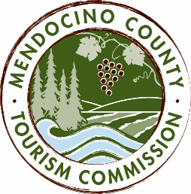

MENDOCINO COUNTY TOURISM COMMISSION, INC.
MARKETING COMMITTEE AGENDA
“The Marketing Committee shall be composed of a maximum of seven (7) voting members as follows: (i) one (1) Director of the Corporation; (ii) six (6) members-at-large; and (iii) the Executive Director or its designee. The Marketing Committee chair shall be elected by a majority of committee members. The Committee shall be responsible for advising and making recommendations to the Board in fulfillment of its duties and obligations regarding all marketing activities and issues, including but not limited to advertising, public relations and website activities.” - bylaws, Article 6, Section 6.1, (d) (iv)
DATE: Wednesday, November 16, 2016
TIME: 9:00AM
PLACE: Little River Inn, 7901 Hwy 1, Little River, CA 95456
CALL-IN: Visit Mendocino County, 390 W. Standley St., Ukiah CA 95482
Visit Mendocino County, 345 N. Franklin St., Fort Bragg CA 95437

CALL-IN: (712) 770-4700 ACCESS CODE: 713704
- CALL TO ORDER
- ROLL CALL
- PUBLIC COMMENT - Brown Act Requirements: Pursuant to the Brown Act, the Committee cannot discuss issues or take action on any requests during the comment period
- APPROVAL OF MINUTES FROM JULY 20, AUGUST 17 & OCTOBER 19, 2016
- MARKETING BUDGET UPDATE; PR EXPENSES TO DATE
- MARKETING & COMMUNICATIONS SUMMIT DATES & PLANNING
- ORANGE COUNTY DIGITAL CAMPAIGN: http://thetravelvertical.com/2016/11/09/orangecounty/
- CANNABIS TOURISM MARKETING
- VIDEO SHOOT UPDATE
- FAMILY TRAVEL WITH COLLEEN KELLY PBS SHOW PROPOSAL
- M IS FOR MENDOCINO PROPOSAL
- MARKETING & PR REPORTS
  - DATA DASHBOARD
  - SEO REPORT
  - PR REPORT

NEXT MEETING DATE
ADJOURN

