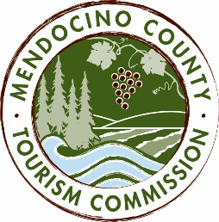

MENDOCINO COUNTY TOURISM COMMISSION, INC.
MARKETING COMMITTEE AGENDA
“The Marketing Committee shall be composed of a maximum of seven (7) voting members as follows: (i) one (1) Director of the Corporation; (ii) six (6) members-at-large; and (iii) the Executive Director or its designee. The Marketing Committee chair shall be elected by a majority of committee members. The Committee shall be responsible for advising and making recommendations to the Board in fulfillment of its duties and obligations regarding all marketing activities and issues, including but not limited to advertising, public relations and website activities.” - bylaws, Article 6, Section 6.1, (d) (iv)
DATE: MONDAY, DECEMBER 12, 2016
TIME: 11:00AM
LOCATION: Visit Mendocino County, 345 N. Franklin St., Fort Bragg CA 95437
CALL-IN: Visit Mendocino County, 390 W. Standley St., Ukiah CA 95482
*Please note: In accordance with the Brown Act, call-in locations must be listed on the agenda. If anyone from the public is calling in during the meeting, it must be done from or at the locations above.

CALL-IN: (712) 770-4700 ACCESS CODE: 713704

- CALL TO ORDER
- ROLL CALL
- PUBLIC COMMENT - Brown Act Requirements: Pursuant to the Brown Act, the Committee cannot discuss issues or take action on any requests during the comment period
- APPROVAL OF MINUTES FROM NOVEMBER 16, 2016
- RESPONSES TO MARKETING COMPANY RFPS
ACTION ITEM: RECOMMEND MARKETING COMPANY TO THE BOARD
- CANADIAN MARKETING CAMPAIGN
DISCUSS TACTICS
- VIDEO SHOOT UPDATE
- HIDDEN OBJECT GAME UPDATE
- DATA DASHBOARD
- MARKETING, SALES & COMMUNICATIONS SUMMIT UPDATE
- TENTATIVE SCHEDULE FOR THE STRATEGIC PLAN
- MARKETING & PR REPORTS

NEXT MEETING DATE
ADJOURN

