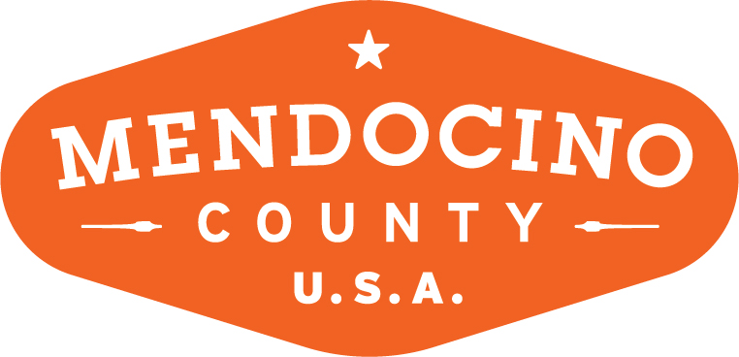

MENDOCINO COUNTY TOURISM COMMISSION, INC.
ORGANIZATIONAL COMMITTEE AGENDA

DATE: Monday September 10, 2018 TIME: 3:00p
LOCATION: 345 N. Franklin Street Fort Bragg, CA
CALL-IN: Redwood Empire Fairgrounds, 1055 N State St, Ukiah, CA 95482

Dial-in Number: 707-479-2400

*Please note: In accordance with the Brown Act, call-in locations must be listed on the agenda. If anyone from the public is calling in during the meeting, it must be done from or at the locations above.
- CALL TO ORDER
- ROLL CALL
- PUBLIC COMMENT –Pursuant to the Brown Act, the Committee cannot discuss issues or take action on any requests during the comment period
- APPROVE MINUTES: Minutes from July 9, 2018
- Board of Director Vacancies (MCTC)
  - Identification of Possible Candidates
  - Next Steps
- BID Advisory Board Vacancies
  - Identification of Possible Candidates
  - Next Steps

NEXT MEETING DATE

ADJOURN

