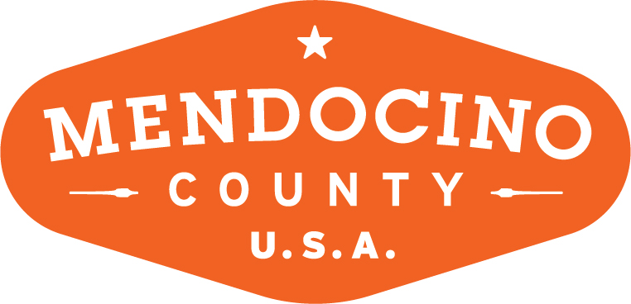

MENDOCINO COUNTY TOURISM COMMISSION, INC.
ORGANIZATIONAL COMMITTEE AGENDA

DATE: Monday August 13, 2018 TIME: 3:00p
LOCATION: 345 N. Franklin Street Fort Bragg, CA
CALL-IN: Redwood Empire Fairgrounds, 1055 N State St Ukiah, CA 95482

Dial-in Number: 707-479-2400

*Please note: In accordance with the Brown Act, call-in locations must be listed on the agenda. If anyone from the public is calling in during the meeting, it must be done from or at the locations above.
- CALL TO ORDER: Sharon Davis called the meeting to order at 3:02pm
- ROLL CALL: Sharon Davis, Wendy Roberts, Jennifer Seward on the phone and Staff Travis Scott
- PUBLIC COMMENT –Pursuant to the Brown Act, the Committee cannot discuss issues or take action on any requests during the comment period
- APPROVE MINUTES: Minutes from July 9, 2018
- Board of Director Vacancies (MCTC)
  - Identification of Possible Candidates
    - Travis has spoken with Anna Beuselinck from Campovida for either BID, Small Lodging or Restaurant. She didn’t totally agree but, didn’t decline.
    - Maegen Loring from Noyo Harbor Inn is willing and has agreed to apply for either the Restaurant seat or Small Lodging.
    - Sharon spoke with Joe Seta who declined he would think of someone in his organization who would possibly apply.
    - Jim Hurst from Crow’s Nest declined and suggested his son Jason Hurst or Troy Barrett. The committee feels neither are great fits for MCTC.
    - Jennifer reached out to Deborah Watson and hasn’t received a call back. She will reach out to Jitu as ask him to stay on MCTC BOD.
    - Wendy suggests keeping the new owners of Café Beaujolais on our potential list for future year recruitment.
    - Sharon Davis has agreed to stay on MCTC BOD unless she can convince one of her BOD members to take her seat. Bernadette Byrne has agreed to stay on the MCTC BOD for another term.
  - Process
    - Travis has updated the letter for Shari to send in September. The Opportunities page on MCTC website is updated and the link to the application is active.
    - Committee members requested a copy of last years BID percentages so that they could help identify potential candidates. As well as the updated Letter of Vacancies. Travis will supply.
- BID Advisory Board Vacancies
  - Identification of Possible Candidates
    - See V.a.i

NEXT MEETING DATE: Monday 9/10/18 3pm VMC Fort Bragg.

ADJOURN: 3:25p

