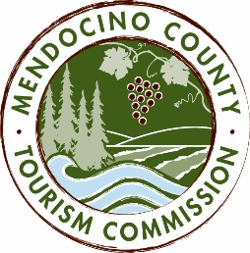

MENDOCINO COUNTY TOURISM COMMISSION, INC.
PERSONNEL COMMITTEE AGENDA

DATE: Thursday, February 25, 2016
TIME: 2:00 pm
PLACE: Visit Mendocino County, 345 N. Franklin St., Fort Bragg CA 95437
CALL-IN NUMBER: 1-605-475-5950 Passcode: 694806

- CALL TO ORDER
- ROLL CALL
- PUBLIC COMMENT
- DISCUSS AND SELECT SEARCH FIRM TO FIND NEW EXECUTIVE DIRECTOR

NEXT MEETING DATE

ADJOURN

