2011-2012 RESEARCH BASED STRATEGIC MARKETING PLAn

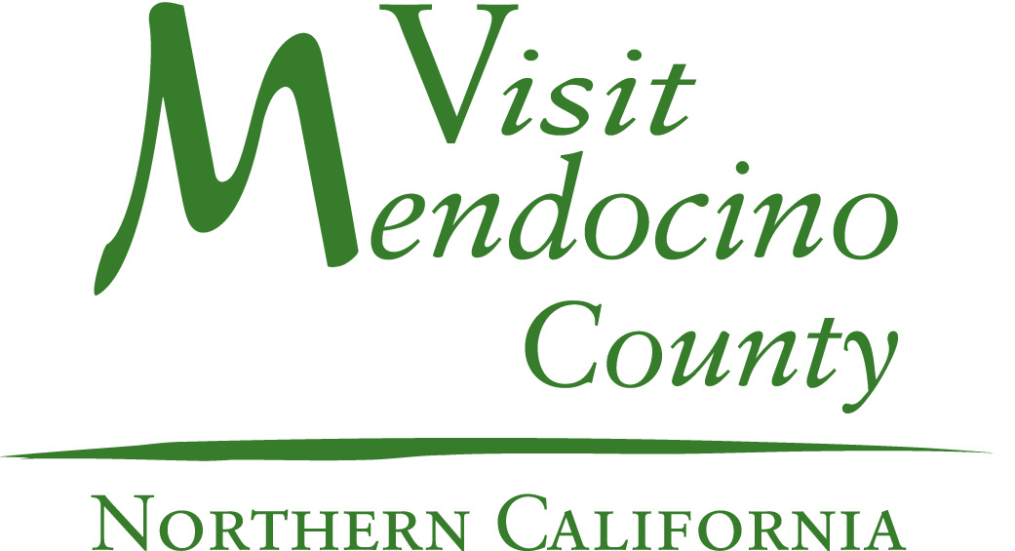
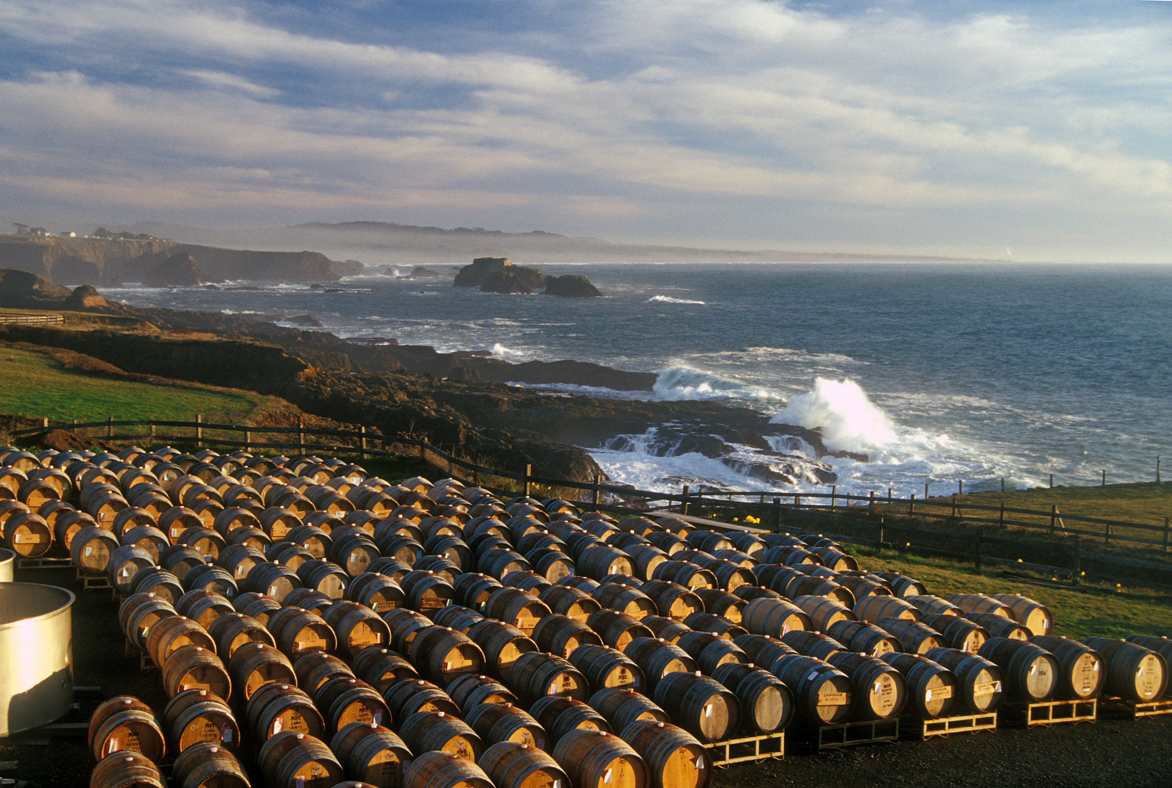
TABLE OF CONTENTS

MISSION 3
GOALS 3
OBJECTIVES 3
GOALS - A SUMMARY...........................................................4
OVERVIEW & BACKGROUND 5
OVERALL STRATEGY 6
ADVERTISING & MEDIA 8
ADVERTISEMENT - KEY PLACEMENT SCHEDULE 8
SOCIAL MEDIA 9
EMAIL MARKETING 10
WEBSITE ADVERTISING 11
WEBSITE DEVELOPMENT & MAINTENANCE 11
PUBLIC & MEDIA RELATIONS 12
SALES – GROUP & LEISURE 14
VISITOR SERVICES & FULFILLMENT 15
VISITOR CENTERS & SIGNAGE 15
REGIONAL PARTNERSHIPS 16
COMMUNITY RELATIONS 17
VISITOR GUIDE & FULFILLMENT 19
TRAVEL & TOURISM ORGANIZATIONAL CHART..……..……..21
STAFFING..…………………….….….…………………..……….….……..22
ADMINISTRATION 23
ROI/MEASUREMENT OF SUCCESS 24
INVESTMENT ANALYSIS 25
CONCLUSION 27

MISSION
Establish Mendocino County as a premier destination featuring quaint and charming villages, towering redwood forests and intimate and unique wineries resulting in high return on investment and increased room nights

GOALS
- Increase overall visitation to Mendocino County, specifically in the shoulder seasons of Spring and Fall

- Increase visitor length of stay

- Increase visitor spending per day

OBJECTIVES
- Place the Mendocino County brand and message in front of potential and repeat visitors through paid and unpaid advertising, articles, and direct contacts

- Create a dynamic social media campaign and encourage local businesses to partner with our efforts including videos, contests, blogs and more

- Continue publication of a high quality visitor guide, website and other necessary materials providing the visitor with the necessary tools needed to plan a multi-day stay in Mendocino County

- Assist community organizations with the promotion of the many events and festivals held throughout Mendocino County

- Assist local visitor centers with support and tools to encourage the customer to extend their stay by at least one day and to spend more money during their visit

- Provide training to local visitor related businesses and organizations helping to improve overall customer satisfaction

- Create an internal Ambassador Program utilizing local businesses, organizations and individuals to encourage participation in our branding, programs and initiatives

- Continue strong partnerships through various initiatives with surrounding counties as well as with the California Travel Industry Association (CalTIA) and the California Travel & Tourism Commission (CTTC)

- Evaluate and measure return on investment (ROI)

goals – a summary
Visit Mendocino County, Inc. (VMC) will focus 2011-2012, its third year of existence, on streamlining its efforts, programs and partnerships. For the past two years, VMC has reached over 90% of its planned goals. At the same time, new programs and initiatives have been added which have proven successful increasing our effectiveness in keeping Mendocino County top of mind to potential and return visitors. Major initiatives will include a more comprehensive social media campaign, creating a brand promise, increasing investment in public relations (PR), providing customer service training, creating a County Ambassador Program and increasing community buy-in.
The following are the measurable goals for 2011-2012:

- Paid Advertising - Initiate approximately 30,000,000 impressions in our target areas producing 7,500 leads through reader response, website hits, phone calls, email, etc.

- Social media - Track campaign success through page views, fans, telephone inquiries and Google Analytics receiving 500 direct inquiries and over 15,000 fans and followers

- Email Marketing - Produce 3,000 leads with an open rate of 20% and click though rate of 5%; and increase subscriptions to 12,500

- Website Development - Increase unique visitors to 225,000 annually; Continue to work on the mobile application; Continue to improve usability of site

- Public and Media Relations - Initiate $5 million in ad equivalency through PR coverage

- Group and Leisure Sales - Obtain 8,000 direct consumer leads and up to 200 small group leads

- Visitor Center and Signage - Install two gateway signs, two informational kiosks; implementation of CalTrans Tourism Oriented Directional Sign (TODS) program, guiding visitors to visitor centers

- Regional Partnerships - Leverage promotional funds to create a travel destination which is nationally known and respected; lead rural marketing efforts statewide

- Community Relations - Continue development of relations with other promotional groups within Mendocino County; implement an Ambassador Program encouraging greater participation in programs, initiatives, events, branding, etc.

- Visitor Guide and Fulfillment - Distribute the 2011-2012 Official Visitor’s Guide, annual events calendar and tear off maps to enhance visitor experience; develop and maintain inquiry database to be used for measuring ROI and planning future marketing activities

overview & background
The travel and tourism economy is vital to Mendocino County. In 2008, approximately 5,400 residents were employed by the travel and tourism industry with total earnings of $124 million. Travel spending in 2008 was $336 million generating approximately $645.00 of annual tax relief for every household within the County. Our mission continues to be focused on increasing overall visitor spending. We are thus creating more tax relief for residents, more employment opportunities, and higher earnings, thereby helping to ensure Mendocino County’s economy is vibrant.

Over the past five years, many committees have been formed to work together promoting the County. Projects such as the redesign of gomendo.com, festival coordination, a promotional video and more, have been accomplished through these committees. It was not until several organizations banded together to conduct a comprehensive research project in 2008 that Mendocino County’s promotional efforts were streamlined to ensure maximum efficiency and effectiveness. The comprehensive Mendocino County Travel Research Study (“MCTRS”) of 2008 contains detailed recommendations on how to market Mendocino County. A complete report and the Executive Summary are available from the Mendocino County Lodging Association (MCLA) MCLA at mcla.info.

Visit Mendocino County, Inc. was established as a not-for-profit 501(c) 6 organization on July 1, 2009. The establishment of VMC enabled MCLA and the Mendocino County Promotional Alliance (MCPA) to work together more closely to create a structure where, essentially, one group is responsible for all aspects of marketing the County. MCLA and MCPA began contracting with VMC for marketing and administration services on July 1, 2009. Combining staff and resources of the two groups enabled those making day-to-day decisions to: become more efficient in their activities; decrease duplication of effort; create a comprehensive approach in achieving key programs and activities for marketing the County, its visitor-serving businesses and organizations, while keeping overhead as low as possible.

VMC was created as a result of the Mendocino County Travel Research Study. VMC is led by a Board comprised of ten individuals – five from the MCLA Board of Directors and five from the MCPA Board of Directors. Members of MCLA’s Executive Committee serve on the VMC Board as well as one other appointed MCLA Board member. MCPA has two Board members representing the wine industry, one representing the art industry, one representing the Chambers of Commerce in the County, and one member-at-large appointed by the MCPA Board. Thus, representation on the VMC Board provides a range of individuals with diverse experience in the promotion of our County.

The primary function of VMC is to carry out this Annual Marketing Plan as approved by the MCLA and MCPA Boards of Directors. The 2009-2010 and 2010-2011 approved Marketing Plans have proven to be major successes. Mendocino County’s promotional efforts at the end of 2008 showed a return on investment of 17:1 – meaning for every dollar spent on promotion, $17.00 of travel spending occurred in the County. At the conclusion of the 2009-2010 fiscal year, closely following the approved Marketing Plan, the ROI showed a 29% increase or 22:1. This return on investment is calculated by correlating the number of inquiries received with the estimated percentage of visitors who come to the County as a result of receiving County information and multiplying that figure by the average daily visitor spending ($491.28 per party as per the 2008 “MCTRS”).

VMC is looked upon as a leader throughout the State. Currently, VMC is responsible for chairing California Tourism’s Rural Marketing Advisory Committee and holds a seat on the California Travel Industry Association Board of Directors. These partnerships are directly responsible for dozens of visiting media, article placements, and opportunities to showcase Mendocino and its products at special events throughout the year.

In almost two years, VMC has proven itself to be the vital foundation for promoting Mendocino County, and enhancing its economic vitality and development. Through its programs and staff VMC has been able to:
- Leverage partnerships with County businesses, organizations and government

- Stay attuned to marketing trends and taking advantage of opportunities to promote the County as a travel destination

- Streamline its operations for most efficient use of resources

- Become the leader in promoting the North Coast region

- Develop a highly effective destination marketing organization for the County

- Consolidate efforts, coordinate strategies, improve professional management practices and provide leadership for other County businesses and organizations within the travel and tourism industry

overall strategy
- Continue to implement the recommended positioning statement promoting our:
  - Coastal Villages and Quaint Towns
  - Unique and Intimate Wineries
  - Towering Redwood Forests

- Create and implement a “brand promise” adding an emotional component to our branding and message

- Stay focused on our target audience in our target areas. This includes travelers in the 35-60 age groups in the San Francisco Bay Area and Sacramento Valley with Southern California, Washington, Oregon and Nevada as secondary markets

- Continue to develop small group and meetings market

- Continue our leadership role in the North Coast Tourism Council, California Travel Industry Association and the California Travel & Tourism Commission

- Facilitate contracts between tour operators, both domestic and international, and local businesses to increase visitation

- Establish a hospitality and customer service training program for County businesses; improving overall customer service throughout the County’s travel industry

- Improve way finding and signage by assisting in placements of informational kiosks and signage including gateway and TODS signage for visitor centers

- Attend trade and consumer shows selling the County directly to potential visitors

- Increase the investment in social media and e-newsletter creating an effective online campaign resulting in a greater presence throughout social media venues

- Provide tools through our Partner Information Packet (“PIP”) to assist County travel related businesses in sharing VMC’s brand and message with their direct publics, further enhancing visitation

- Maintain and continually develop visitmendocino.com, making it an essential “cruise ship on land” for planning and informational purposes

- Increase our public relations effort aimed at increasing our exposure in the media around the globe building on the “buzz” created over the past few years

- Advertise using radio, online, TV, outdoor and print media maintaining a diverse media plan to create awareness and encourage new and repeat visitors to the County. Work to establish more partnerships with publications rather than the traditional publication/advertiser relationship

- Distribute the third and produce the fourth annual Mendocino County Official Visitor’s Guide to assist with travel planning. Maintain a downloadable PDF version for visitmendocino.com

- Implement an Ambassador Program utilizing individuals throughout the County assisting in communicating our activities, opportunities, etc., with the goal of increasing participation and buy-in

- Encourage businesses to participate in co-operative advertising, trade shows, VMC sponsored publications, and website publications through a new affiliation program

- Continue to track inquiries to determine which marketing avenues are most effective and bring the greatest return on investment

- Continue to promote the “Mushroom and Wine Festival” and “Crab and Wine Festival” obtaining media/VIP judges for events, organizing countywide familiarization tours, etc.

- Explore developing and promoting a third festival in April focusing on Mendocino County’s sustainable lifestyle

- Continue to be a significant resource to organizations coordinating events and festivals with the goal of maximizing efforts, increasing visitation and creating a “buzz” regarding the events

- Maintain a leadership role in the California travel and tourism industry, making Mendocino County “top of mind” as a leading sustainable and leisure destination

advertising & media
Strategy:
- Develop a media plan which will generate consumer requests, leads, visitation to website and drive an increase in room nights booked throughout Mendocino County

- Spend advertising dollars where return on investment is highest growing by forming partnerships with publications doing more than just traditional print advertising (i.e., Innovative Radio)

- Create and utilize a brand promise that not only VMC can use in its messaging and advertising, but any visitor serving business in the County can use appropriately

Tactics:
- Partner with the Mendocino Winegrape & Wine Commission (MWWC) in marketing events and festivals throughout the year primarily focused on outdoor, radio and online venues

- Encourage County businesses to co-op with us increasing exposure and effectiveness

- Advertise in Sacramento, San Francisco and California’s visitor guides getting the most out of their promotional budgets and efforts

- Expand current publication relationships to build partnerships/sponsorships with the goal of getting more editorial coverage and value added promotion

Advertisement - key placement schedule
GREATER CALIFORNIA
2012 CA Visitor Guide and 2012 CA Road Trips– ½ page
VIA Magazine – 3 wine country page placements and 2 co-ops
Sunset Magazine – Fully integrated print, online and email campaign
California Travel & Tourism Co-Operatives (Budget Travel, Coastal Living, etc) – Fall and Spring
Fido Friendly Magazine – 6 paid ads placed every other month
SAN FRANCISCO BAY AREA
San Francisco CVB – Official Visitor Guide and other consumer publications
San Francisco In-Room City Guide - Annual
SACRAMENTO VALLEY
Sacramento CVB – Official Visitor Guide
SacTown Magazine – ads in travel issues (Fall and Spring)
Sacramento Bride Magazine – Dec 2010 – June 2011 (one issue)
ON-LINE ADVERTISING
sunsetgetaways.com – added value
viamagazine.com/info – added value
Inroomcityguide.com – added value
KGORadio.com – added value
E-MAIL BLASTS
Opportunistic – strategize specific email lists throughout year targeting specific areas and times
RADIO – KGO interactive campaign – 6 weeks in Fall; 6 weeks in Spring
TV Campaign – in-county to encourage longer stays
OUTDOOR ADVERTISING
Goal:
- Initiate 30,000,000 impressions in our target areas generating at least 7, 500 leads

social media
Strategy:
- Use the latest in social media platforms to market and brand Mendocino County as a unique leisure destination; increasing web traffic to VisitMendocino.com and, ultimately, visitation to the County

- Generate and create a consistent image/message which appeals to our broad target audiences

- Partner with local organizations and businesses to maximize social media efforts and results
Tactics:
- Continue to develop and improve Visit Mendocino County, Inc. profiles on Facebook.com, Twitter.com, Youtube.com, and Flickr.com

- Update the Visit Mendocino County, Inc. blog on a monthly basis. Partner with other Mendocino County bloggers to generate area and interest based content which will be aggregated into the Visit Mendocino County blog

- Continue to develop a “Mendo Moments” YouTube campaign promoting Mendocino County. Video content to be created by staff, community members and visitors. Videos to be incorporated into all social media and website campaigns

- Explore the possibility of a “My Life in Mendocino County” campaign utilizing celebrities – known both locally and worldwide

- Link all social media campaigns to VisitMendocino.com

- Make a consistent effort to highlight upcoming events and specials on social media websites. Utilize pictures and videos to emphasize and encourage increased viewer ship

- “Follow” and “Fan” other visitor serving businesses throughout the County with the hope that their message as well as ours will be broadcast to an even broader audience

- Initiate contests and other engaging activities throughout the social media platform encouraging an increase in followers and fans, driving visitation to Mendocino County
  - Photo contest
  - Mendocino Moments
  - Check-In Campaign
  - Ideal Vacation Campaign
  - What’s New Campaign
  - Pet Friendly Campaign

Goal:
- Receive 500 direct inquiries with a total of 15,000 fans and followers

email marketing
Strategy:
- Drive traffic to VisitMendocino.com by using visitor e-newsletters promoting County events, activities, special interest stories, specials and packages

- Visit Mendocino County, Inc. staff will continue to capture email addresses at tradeshows, festivals and events, via the VisitMendocino.com website, social media platforms and 1-866 numbers
Tactics:
- Distribute scheduled e-blasts promoting festivals, events and specials a month in advance to allow potential visitors time for travel planning

- Initiate 2011-2012 schedule of e-blasts and corresponding promotional banners on VisitMendocino.com as follows:
  - July - Pet-Friendly and Family Travel in Mendocino County
  - August - Wine Events and Overall Winery Promotion
  - September - Day of the Dead and other Halloween Events
  - October - Wine and Mushroom Festival
  - November - Thanksgiving and Christmas in Mendocino County
  - December - Crab and Wine Days
  - January - Valentine’s Day and Romance Packages; Alsace Festival
  - February - Whale Migration and Festivals
  - March - Earth Day ,Kids and Nature Promotion, Wildflowers in Mendocino County
  - April - Festival Spotlight: Beer Fest, Pinot Noir Festival, Film Festival
  - May - Getting Married in Mendocino and Renewing Romance
  - June - July 4th events in Mendocino County, Frontier Days, Music Festival

- Encourage development of “outstanding specials and packages” with County businesses to increase visitation and length of stay, to be included in email marketing

- Link email campaigns to other social media platforms to increase overall social media efforts: “Follow us on Twitter, Facebook, etc.”

Goal:

- Increase e-newsletter subscriptions from 7,800 in March 2011 to 12,500 in June 2012

website advertising
Strategy:
- Have VisitMendocino.com appear on the first page(s) of results on key search engines such as Google, Bing, etc. highlighting all the County has to offer

Tactics:
- Search Engine Optimization – Continuously improve the website’s organic performance on search engines through quality and extensive website content

Goal:
- Be at the top of relevant organic searches

website development & maintenance
Strategy:
- Continue to develop VisitMendocino.com with rich and dynamic content whether viewed on a computer, mobile phone or other platform(s)

Tactics:
- Adjust website features and functionality with the goal of providing an easy, comprehensive and rewarding experience to the website visitor

- Work with local visitor related businesses to enhance their listings and provide links to VisitMendocino.com

- Enhance VisitMendocino.com mobile site as appropriate

Goal:
- Increase the current unique visitors up to 200,000 from its current 175, 000 annually

- Continue with Phase 2 of mobile phone application

public & media relations
Strategy:
- Build the overall Mendocino County message in key target areas, through:
  - Media, (includes editors and producers in print and broadcast)
  - Key VIP travel and media opinion leaders
  - Internet media, including media bloggers and industry buzz makers
  - Key government leaders
  - Internal audiences, including board members and County leaders/decision makers as well as visitor related businesses and organizations

- Recruit editors and media leaders to include coverage of Mendocino County’s lodging, events, attractions, latest news and stories in articles, news stories, broadcast news shows and internet communications

- Collaborate with other countywide public relations efforts in order to maximize efforts and results including, but not limited to, the Mendocino Winegrape & Wine Commission

Tactics:
- External Key PR Actions
- Plan, direct and execute a complete media relations and public relations campaign designed to achieve the goals and objectives of VMC
- Conduct verbal and written pitches to editors and industry leaders
- Continue development of press kit
- Plan, produce and executive a new Visit Mendocino County video to share the Wine, Waves and Wilderness story with press and travelers. Also produce official B-Roll video compilation video for broadcast press
- Research, write and distribute at least two press releases per month
- Assist with monthly consumer e-newsletters
- Assist with overall social media campaign focusing on media components
- Provide PR media training as directed by VMC’s CEO/President
- Assist with coordination and execution of County business showcases in different areas of the County to enhance communication and knowledge between HypeHouse and County businesses. Showcases to provide a forum for local businesses to share their news stories and for VMC to share marketing resources
- Provide advance press kits and follow up information, as appropriate, to businesses who host journalists
- Assist with consumer trade shows focusing primarily on the media component in:
  - San Francisco Bay Area (includes Bay Area Travel Show, Bridal Show and Sunset Celebration Days)
  - Sacramento, including Sportsman Show
  - Support all shows with marketing and event management planning

- Set up media “desk sides” in:
  - New York City
  - SF Bay Area
  - Sacramento
  - Los Angeles
  - And other key cities as opportunities, time and budget permit
- Attend California Travel and Tourism Commission Media events in New York and Los Angeles. Research and report on doing our own media event in New York City for 2012
- Plan and coordinate a special Mendocino County showcase event in the Bay Area (i.e., Taste of Mendocino) to be attended by editors, producers, travel VIPs and industry opinion leaders
- Assist VMC with developing its international tour business
- Assist VMC with appropriate public relations aspects for regional marketing co-op programs
- Enter VMC into award competitions for marketing and communications campaigns

- Internal Key PR Actions
- Build and update the overall activity and launch interactive online calendar
- Write and coordinate all components necessary to pitch editor and media targets, including: press releases, fact sheets, media lists and more. Update the official press kit and support materials. Outline new online press room for VisitMendocino.com Maintain site as key journalist resource
- Participate in a weekly conference call with staff to review actions, timelines and campaign details and provide monthly written updates
- Assist with applying for marketing awards
- Provide a compilation of all articles, press releases and any other relevant data/documents resulting from the campaign, including a chart of all media who has visited, where they stayed, what they did, etc. Quarterly reports will be developed and this information will be included in an annual “PR Bible” for the contracted year
- Provide assistance with MCLA’s annual meeting
- Provide copy for MCLA’s quarterly newsletter and other relevant internal communication pieces informing members and the community of the public relations efforts and successes
- Manage a comprehensive clipping service for all Mendocino County articles relative to promotion
- Establish VMC team protocol for crises and overall message communications as they relate to media
- Research and define new measurement and ROI standard for PR and Marketing Communications elements and campaigns

Goal:
- Increase overall impressions to 120,840,000 with $5 million in ad equivalency and public relations coverage – a 20% increase over previous year

Sales - group & leisure
Leisure Sales:

Strategy:
- Direct face to face contacts with travel professionals as well as consumers in a position to recommend leisure travel destinations

- Sell Mendocino County directly to target audiences at consumer travel shows in target markets

Tactics:
- Leverage memberships with Sacramento and San Francisco Convention and Visitors Bureaus (CVBs) to increase individual and group leisure travel

- Attend consumer shows including the Bay Area Adventure & Travel Expo, Sacramento Sportsman Show, Bay Area Bridal Show(s), Bark in the Park and Sunset Celebration Days

- Research and identify other trade show opportunities with significant return on investment possibilities. These include niche travel and trade shows such as pets, Lesbian, Gay, Bi-Sexual and Trans-Sexual groups (LGBT), wine, nature, “green”, etc.

- Develop pay-to-play opportunities at consumer shows with County businesses to increase overall impact

- Encourage development of “outstanding specials and packages” with County businesses to increase visitation and length of stay when selling Mendocino County

- Evaluate each show attended and provide recommendations for subsequent years based on return on investment

- Host booth at State Fair in Sacramento in July featuring unique aspects of County. Partner with local organizations and businesses to staff booth at least each weekend of Fair

Goal:
- Obtain 10,000 direct consumer leads – a 25% increase over previous years

Group Sales:
Strategy:
- Increase small group business to Mendocino County by creating a small group infrastructure and establishing an awareness of options among those who provide group business

- Pursue dual strategy of contacting convention and meeting event planners and CVBs to encourage group business in connection with target area conventions. In addition, attend trade shows dedicated to exposing event and meeting planners to potential Mendocino County destinations

Tactics:
- Continue to develop relationships with all major CVBs in our target areas. Continue active membership with the San Francisco and Sacramento CVBs

- Attend, with key tourism players on a pay to play basis, conventions where event and meeting planners meet to explore destinations, specifically the Meeting Planners International Convention and Trade Show in San Francisco

- Develop group packages for spousal side trips, business meetings, Board of Director/executive meetings and retreats; packages which can be sold to planners and convention logistic specialists

- Continue to develop and distribute a countywide meetings and small group guide

- Personally contact identified event planners for conventions in target areas

Goal:
- Obtain up to 200 small group leads – a 100% increase over previous years

visitor services & fulfillment

visitor centers & signage
Strategy:
- Pursue a two prong strategy of enhancing existing visitor centers and establishing informational kiosks and signage at County gateways and high traffic areas

Tactics:
- Meet with existing visitor centers in Fort Bragg, Mendocino, Ukiah, Willits, and the Redwood Coast to ascertain their needs and the extent to which we can assist in fulfilling those needs

- Conduct an RFP process for possible funding opportunities to in-County visitor centers. Examples include extending hours, providing bathroom facilities and signage, assisting with visitor initiatives, etc.

- Establish permanent attractive County gateway signage on Highway 1 in the Gualala area and South Highway 101 near the Mendocino County line. Identify possible locations on Highways 20 and 128 for future gateway signs

- Establish new gateway kiosks in Boonville and Westport. Assist in their creation and implementation

- Continue work on planning for Confusion Hill visitor services including signage

- Plan for unmanned kiosks for both in County and out of County locations. Develop prototypes and do preliminary location planning

- Explore consistent way finding signage working with CalTrans’ TODS program, with the MWWC, helping to direct visitors to visitor information centers throughout the County

- Explore opportunities with “Adopt a Highway Program”

Goal:
- Installation of two gateway signs and two informational kiosks throughout the County

- Assist local visitor centers in enhancing visitor experience through increased hours and services

regional partnerships
Strategy and Tactics:
- To maximize and leverage our resources in the promotion of Mendocino County through involvement and leadership in regional and statewide organizations, partnerships and initiatives

- Chair and administer the North Coast Tourism Council, including collaborating and strategizing with neighboring counties

- Continue to be a member of the California Travel Industry Association Board of Directors as well as a regional Ambassador

- Chair the California Travel & Tourism Commission’s Rural Advisory Committee

- Sponsor CTTC’s third annual Sustainable Tourism Symposium and serve on its planning committee

- Continue to be a leader in the North Coast Geotourism Initiative. Attempt to maximize Mendocino County exposure to this project by:
  - Serving as Mendocino County gatekeeper for VisitMendocino.com
  - Working with partners on website enhancement
  - Seeking grants to fund site optimization

- Continue to be a leader in the Redwood Coast National Heritage Area by:
  - Assisting in project completion scheduled for 2012
  - Seeking grant funds, when appropriate, capitalizing on designation
  - Actively lobbying with local, regional, state and national officials
  - Preparing necessary documentation for implementation of Heritage Area

- Assist in the development and coordination of the “Confusion Hill” visitor center/kiosk by:
  - Working with consultant in the development of a plan for a gateway visitor center, scenic vista, County Park and/or interpretive trails

- Distribute countywide themed guides and other VMC sponsored promotional materials

- Administer the Mendocino County Promotional Foundation and its committees
  - Apply for grants on behalf of the Foundation for educational and promotional activities to further the goals of the Foundation and to assist other Mendocino County non-profits working to increase visitation to Mendocino County

- Maintain and oversee content on websites such as gozaic.com, VisitCalifornia.com and other relevant travel industry related websites

- Explore unknown and yet to be determined local, regional, state and national partnerships with the mission of enhancing the Mendocino County visitor experience

- Explore membership in Destination Marketing Association International with the goal of making VMC a leader among destination marketing organizations in the US and abroad

Goal:
- Leverage our promotional funds to create a Northern California travel destination which is nationally known and respected

community relations
Strategy:
- Continue to work with Mendocino County promotional businesses and organizations, local government, Chambers of Commerce and others in further enhancing County promotional efforts with the understanding that partnerships and cooperation increase effectiveness for all of those involved

Tactics:
Promotional Organization Relations
- Communicate to other County promotional organizations the information contained in this Marketing Plan as well as other activities and efforts performed by VMC

- Attend one regional Chamber mixer per quarter to promote VisitMendocino.com

- Continue to partner closely with the Arts Council of Mendocino County in making the arts a compelling reason for a multiple day stay

- Continue to partner closely with the MWWC in promoting the uniqueness and “greenness” of Mendocino County’s wine country

Hospitality and Customer Service Training
- Develop, support and partner to produce community training, and/or seminars that benefit economic development and tourism through enhanced visitor experiences

- Implement a countywide hospitality customer service program training individuals working directly with visitors on proper customer service as well as the many assets of Mendocino County

Community Showcases
- Continue meeting with visitor serving businesses distributing our Partner Information Packets, encouraging partnership and successful marketing

- Conduct showcases throughout the County, communicating the programs and initiatives as outlined in this Marketing Plan and encouraging buy-in and partnership

Event Partnership & Coordination
- Contract with a year-round event coordinator to assist with the coordination, promotion and participation of the Crab & Wine and Mushroom & Wine festivals and other approved countywide festivals

- Work on development and promotion of a new countywide festival focusing on Mendocino County’s sustainable and eco-lifestyle

- Encourage businesses to offer event-related specials and packages to increase the viability of events and visitor opportunities and encourage an increase in length of stay

- Assist events and festivals as appropriate with the goal of improving promotion and attendance of out-of-County visitors throughout the year

- Collaborate with event planners to establish new event opportunities and partnerships

- Maintain communications with other agencies to distribute event announcements to member mailing lists

- Coordinate countywide bi-annual event calendar promotional piece featuring major events/festivals in County

- Ensure County events are listed on visitmendocino.com

- Coordinate annual Mendocino County wall calendar depicting major events in County through photography and sponsorships

- Continue to work in making VisitMendocino.com the go-to event calendar for Mendocino County

- List events on relevant regional, state and national web-based calendars

- Attend and participate in County festivals and events and to the extent possible in similar events in our target areas

Ambassador Program
- Utilize residents and local businesses to learn and share our message and marketing goals

Goal:
- Continue development of relations with other promotional groups within Mendocino County

- Increase visitation to festivals by increasing number and improving promotion of events

- Increase buy-in from local residents and businesses enhancing programs and initiatives

visitor guide & fulfillment
Objective:
- To provide the potential visitor, in our target areas, with high-quality, easy to use visitor information and travel planning guides

Strategy:
- Produce collateral materials with a consistent, uniform message which reflects the VMC brand; providing up to date, accurate information to potential and current visitors

Tactics:
Tear Off Maps
- Continue development of inexpensive tear off maps to help with visitor way finding and promotion. Finished map pads will be distributed to hotels, attractions, restaurants, etc., in appropriate region(s). Visitor centers will have all regional maps as made available by VMC

Official Visitors Guide
- Produce the fourth annual Official Mendocino County Visitor’s Guide, improving upon the first edition. Guide to be completed by June 2012

- Distribute approximately 65,000 of the 2011-2012 Guide to regional visitor centers, California Welcome Centers, CVBs, AAA offices, consumer and trade shows, media requests, consumer inquiries, local and regional events and other travel outlets

- Distribute approximately 7,000 of the 2011-2012 Guide to local lodging establishments providing “in room” copies for current visitors with the goal of increasing length of stay and overall visitor spending

- Distribute approximately 3,000 of the 2011-2012 Guide to local visitor centers and information kiosks

Other Promotional Materials
- Produce a semi-annual events guide promoting the multitude of events throughout Mendocino County

- Produce a 2012 wall calendar showcasing Mendocino County photography, history and facts as well as festivals and events occurring throughout the year. Encourage businesses to sponsor months within the calendar

- Encourage specific industries to continue production of countywide maps highlighting their industry. Examples include: Art, Culture and Gallery, Nature Tourism, Wine

- Support efforts of others throughout the County in producing and printing event/festival guides as appropriate

Photo and Video Library
- Maintain and add to the VMC digital photo and video library of Mendocino County attractions, events, landscapes, etc.

- Continue to photograph and video events and activities for use in promotional efforts

Fulfillment Services & Inquiry Database
- Coordinate the fulfillment program through the use of existing 1-866 numbers, VisitMendocino.com, and all other promotional efforts as outlined in this Plan

- Maintain an in-house, query based database which contains all visitor inquiries and leads. Visitor inquiries and leads will be organized to provide inquiry statistics by ad type, inquiry location, date, source, etc.

Goal:
- Produce the 2012-2013 Visitor’s Guide

- Distribute the 2011-2012 Visitor’s Guide, annual events calendar, industry specific fulfillment pieces and tear off maps to enhance visitor experience

- Assist in development, production and distribution of other countywide promotional materials including agriculture trails

- Develop and maintain inquiry database to be used for measuring return on investment and planning future marketing activities

travel & tourism organizational chart

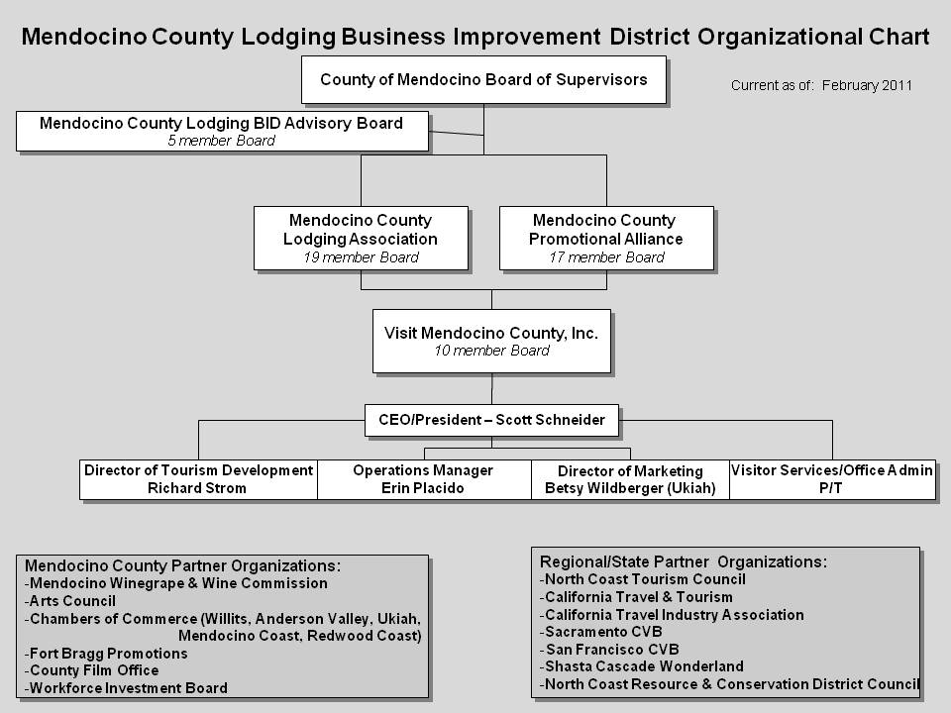

staffing
Objective:
- Create and sustain a staffing structure which will be an efficient and effective marketing organization for the promotion of Mendocino County

- Procure motivated, experienced individuals to successfully and efficiently implement this Plan

Strategy:
- Visit Mendocino County, Inc. staff will work with a VMC Board appointed committee to maintain the following structure and individuals for staffing:

- President/CEO, Scott Schneider
  - Reports to VMC Board of Directors
- Specific Duties and Responsibilities for:
    - Providing Media Planning and Oversight
    - Directing PR Efforts
    - Establishing and Maintaining Regional and State Partnerships
    - Directing Research Comparability with State of California
    - Providing Executive Management and Leadership for all VMC activities
    - Providing Administrative Services to the MCLA and MCPA Boards
    - Attending all boards and committee meetings, as appropriate
    - Developing and Implementing Marketing Plan and Annual Budget
    - Preparing MCLA and MCPA Quarterly and Annual Reports and presenting them to the County, as appropriate
    - Establishing and Maintaining Community Relations
    - Chairing the North Coast Tourism Council
    - Establishing and Providing Liaison to other regional and State travel related organizations

- Director of Marketing, Betsy Wildberger
  - Reports to the President/CEO
- Specific Duties and Responsibilities for:
    - Overseeing Media Plan execution
    - Administering Media Committee
    - Representing VMC on a daily basis from Ukiah office
    - Developing and Maintaining-
        - Email Database for Future Marketing
        - E-Marketing and Social Networking Media
        - Inquiry Database
        - Annual Evaluation Point of Origin
    - Providing Liaison to Mendocino County Promotional Foundation
    - Assisting CEO : Inland Chamber Relations
    - Assisting CEO with MCPA Member Relations
    - Assists in the Development of Tourism Education, Festivals, State Fair, Capitol Display

- Director of Tourism Development, Richard Strom
  - Reports to the President/CEO
- Specific Duties and Responsibilities for:
    - Establishing and Maintaining –
        - Co-Op Marketing
        - Leisure Tourism Sales
        - Group Sales
        - International Sales
    - Overseeing Consumer and Trade Shows
    - Developing and Conduction Consumer Training
    - Developing and Updating Specialized Brochure
    - Planning and Developing Visitor Information Kiosks
    - Overseeing the Provision of General Visitor Services
    - Planning and Developing Gateways, Visitor Centers, Way finding, and Signage
    - Providing Coordination to Partner Projects including, National Heritage Area and Geo-Tourism
    - Identifying and Preparing Grants to support specific partnerships and projects
    - Performing other special projects, as assigned

- Operations Manager, Erin Placido
- Reports to the President/CEO
- Specific Duties and Responsibilities for:
    - Preparing and Conducting Annual Lodging Survey
    - Assisting with Hospitality Training
    - Act as:
MCLA Administrator
NCTC Administrator and Event Planner
MCPA Administration
MCLA Administration
VMC Administration
    - Assisting CEO with Coast Chamber Relations
    - Assisting CEO with MCLA Member Relations
    - Assisting the President/CEO in the completion of assignments
    - Assisting with Social Networking

- Office Assistant, Fort Bragg
  - Reports to the Operations Manger
  - Specific Duties and Responsibilities for:
    - Assisting with general office tasks – mailings, data entry
    - Assisting with website review and editing
    - Performing other office related tasks as directed
Goal:
- Visit Mendocino County, Inc. staff will perform as a single cohesive team responsible for the development and implementation of the Marketing Plan

administration
Objective:
- Maintain functionality of organizations while keeping costs at a minimum

Strategy and Tactics:

Visit Mendocino County, Inc. Administration:
- Performs all tasks as directed by the Visit Mendocino County, Inc. Board of Directors, including the implementation of this Marketing Plan
- Office Location and Hours:
  - Offices are located in downtown Fort Bragg and downtown Ukiah
    - Inland Office – 309 East Perkins Street; Phone: (707) 462-7417
    - Coastal Office – 120 South Franklin Street; Phone: (707) 964-9010
  - Offices are open Monday through Friday from 8:30 am to 5:00 pm

MCLA Administration:
- Provides Contracted Administrative Services to MCLA
  - Staff will perform administrative tasks as directed by the MCLA Board of Directors as well as those as outlined in MCLA’s contract with the County and the BID Ordinance
MCPA Administration:
- Provides Contracted Administrative Services to MCPA
  - Staff will perform administrative tasks as directed by the MCPA Board President as well as those as outlined in MCPA’s contract with the County
  - Tasks include meeting preparation, member communication, accounting/ bookkeeping, website maintenance, reporting minutes, and others as requested
  - Provide contracted administrative services to the Mendocino County Promotional Foundation
Goal:
- Performs all administrative tasks ensuring all organizations function optimally in their fulfillment of their specific missions, following all By-Laws, policies, plans and procedures

rOI/measurement of success
Objective:
- Measure success of programs and initiatives, including implementation, to ensure significant return on investment on resources provided

Strategy & Tactics
- Annual Update to Performance Review
- An annual update will be performed in Summer 2012 which includes:
  - Changes in occupancy tax collections
  - Number of inquiries generated by outreach efforts
  - Advertising, promotion and marketing budget for Mendocino County compared to standards established by Destination Marketing Association International (DMAI)

  - Research Comparability with the State of California
- Maintain regular contact with the state tourism division and compare current research findings to those available from the state

- Annual Evaluation point of origin
- To better focus marketing dollars, staff will perform an annual point of origin evaluation of our inquiry database by zip code. This data will help us determine where best to place our marketing and advertising dollars for the next fiscal year

- Leads Analysis
- Analyze leads from advertising to measure return on investment. This includes specific Website URL’s for all print ads, reader response card requests, banner ad click through rates, and general inquiries. This data will help determine the effectiveness of the many different media where advertisements are placed and will assist in future planning

Goal:
- Obtain the required information to measure success as well as assist in the planning and development of the following year’s Marketing Plan
- Obtain the necessary information in order to continue to be a research based marketing destination organization

investment analysis
The following charts provide breakdowns where monies are to be spent in the general categories outlined in this Plan.

Chart #1: Breakdown of Media, Visitor Services and Administration by percentage. This includes staffing and resources involved with respective categories (i.e., staff time spent on media is included in the media percentage)
TOTAL INVESTMENT = $937,325 (100%)

Chart #2: Breakdown of Staffing by percentage. This explains how much time all staff devotes to Media/PR, Visitor Services/Partnership and Administration. This includes all personnel related expenses (taxes, insurance, etc.)
TOTAL INVESTMENT = $293,000 (31%)

Chart #3: Breakdown of Marketing Activities by percentage. This explains actual costs spent on media, PR, Website, Sales, Visitor Services and Partnerships and does not include staff time.
TOTAL INVESTMENT = $577,000 (61%)

Chart #4: Breakdown of Administration Activities by percentage. This explains actual costs spent on MCLA, MCPA and Visit Mendocino County, Inc. Administration (rent, supplies, postage, insurance etc.). This does include staff time devoted to all administration.
TOTAL INVESTMENT = $102,160 (11%)

conclusion
Visit Mendocino County, Inc. takes pride in the role it plays in the prosperity, health and vitality of the County. Visit Mendocino County, Inc. is the point of convergence and principle source of information for visitors and residents seeking information about Mendocino County’s tourism attractions and activities. The destination attitude fostered by Visit Mendocino County, Inc. serves as the catalyst to the travel industry within Mendocino County and as a magnet for visitors. Along with its hospitality industry partners, Visit Mendocino County, Inc. strives to provide consistently excellent services for the visitor. Our strategic goals reflect this commitment to excellence as well as provide the framework for assuring Visit Mendocino County, Inc. will continue to be a worthy and effective steward of public funding and trust.

Visit Mendocino County, Inc. has already proven its effectiveness and importance. Visit Mendocino County, Inc. continues to increase its return on investment – with the intention of increasing ROI an additional 10% over the 22:1 measurement as of March 2011.

Visit Mendocino County, Inc. is more determined than ever to help maintain travel and tourism as a pillar for Mendocino County’s economic health.


